Public Transport Launch Center
Management System

Senior project 2

Prepared by :
Mohamad Al Nasser
Under the supervision of :
Eng. Ranya Rajab

Dedication
To those who cleared the thorns from my path to pave the way for my journey of knowledge.. To my dear and generous parents..
To my esteemed teachers who never withheld knowledge or guidance from us..
To my colleagues and friends, and to everyone who contributed with a footstep or an idea in accomplishing this programming work..
We dedicate this humble effort to you.

مستخلص المشروع:
يعاني قطاع النقل العام البري بين المحافظات من عشوائية إدارية واعتماد كلي على المعاملات الورقية التقليدية، مما يؤدي إلى مشاكل في تنظيم المواعيد، تلاعب بأسعار التذاكر، وضياع شكاوى المواطنين. يقدم هذا المشروع حلاً برمجياً متكاملاً لأتمتة وحوكمة "مراكز انطلاق الحافلات" (الكراجات الموحدة).
تم بناء النظام باستخدام هندسة برمجية متطورة تعتمد على معمارية الخدمات المصغرة (Microservices Architecture) عبر بيئة عمل .NET 8 للخدمات الخلفية، وإطار عمل Reactلبناء واجهات المستخدم، مع عزل قواعد البيانات لكل خدمة باستخدام SQL Server وحزمها داخل حاويات Docker. يوفر النظام واجهات متزامنة تخدم خمسة أطراف: إدارة الكراج لضبط الرحلات والعمليات التشغيلية الانطلاق والخطوط، السائقين لمتابعة الرحلات، والمواطنين لحجز المقاعد وتقديم الشكاوى الفورية المربوطة بالرحلة. منظم الطابور ومدقق الرحلات.
تم إخضاع النظام لاختبارات أداء وضغط مكثفة لضمان استقرار البوابة البرمجية وسرعة الاستجابة تحت ظروف الضغط العالي.

Abstract
Inter-provincial public transportation centers face significant operational challenges due to manual paper-based management, resulting in scheduling inefficiencies, ticket price manipulation, and unhandled passenger complaints. This project proposes a comprehensive software solution to automate and govern "Public Transport Launch Centers" (Unified Terminals).
The system is engineered using a modern Microservices Architecture via .NET 8 for the backend services and React for building responsive user interfaces. Each service manages an independent SQL Server database, fully containerized using Docker. The platform integrates three synchronized interfaces to serve key stakeholders: Garage Administrators (to control dynamic line queuing), Bus Drivers (to track assigned shifts), and Citizens (for digital ticket booking and real-time complaint submission tied directly to trip data). To ensure system reliability and high availability, the architecture was subjected to rigorous performance and load testing, verifying optimal response times under heavy concurrent user traffic

Table of Contents
Chapter One Introduction and 13
Project Definition 13
Introduction to the Project Topic 14
1-Overview: 14
2-Project Justifications 14
3-Project Objective 14
4-Project Scope Assumptions and Restrictions 15
4.1. Project Scope 15
5-The project's contribution to Knowledge and the field F(What is New) 16
6- Research Methodology 16
7-Basic Definitions and Concepts 17
Chapter Two 18
: Project Development and Management Methodology 18
1-Project Definition 19
2-Project objective 19
3-Scope 19
4-Development Method Used (Iterative Incremental) 20
5-Work plan 21
6-Project charter 21
7-Roles and Responsibilities 22
8- Risk management 22
9- Project Quality Management 23
Chapter3 Reference study 24
1.For the field study and stakeholder analysis 25
1. Interview Profile 25
2. Interview Themes & Problem Identification 25
Similar applications 26
3.Modern technologies and frameworks in the field 28
5. Modern and Future Directions in the Field (Future Trends in the Field) 29
Chapter 4 : 30
Analytical 30
study 30
2-Requirements Elicitation 31
3-stakeholders 31
4-functctional requirements 32
5-Nonfunctional requirement 33
6-Prioritization of requirements and the mechanism for their management 33
7-system description of features(High level use case diagram) 34
7-1-Main Use Case Diagrams 35
87-2- use case Descriptions 36
7-3-Activity Diagrams 43
7-4-Sequence Diagrams 45
7-5-Requirements Traceability Matrix 47
7-6-Test Case Descriptions 49
Chapter 5 50
Architectural Design 50
5.1 System Architectural Design 51
1. First Tier: Client-Server Architecture 51
2. Second Tier: Microservices Architecture 51
3. Third Tier: Clean Architecture (4 Layers) 53
5.2 Database Design 53
5.2.1 Entity Relationship Diagram (ERD) 54
5.2.4 class diagram high level 55
5.3 API Design 57
5.4 Security and Authorization Design 59
5.4.1 Authentication Mechanism 59
5.4.2 Authorization and Access Control 61
5.4.3 Access Levels 62
5.4.4 API Security Measures 63
5.4.5 Security Architecture Overview 63
Chapter 6 64
DEVELOPMENT ENVIRONMENT AND TOOLS 64
6.1 Introduction 65
6.2 Development Tools and Software 65
6.3 Development Environment and System Structure 65
6.3.1 Root Directory Structure 66
6.3.2 Backend Structure 66
6.3.3 Microservice Internal Architecture 67
6.3.4 Frontend Structure 67
6.3.5 Performance Testing Structure 68
6.4 Programming Languages and Frameworks 68
• Framework 68
6.5 Database Server and Operating System 69
6.6 Dependencies and Libraries 69
6.7 Version Control and Source Code Management 69
6.9 Testing Environment 70
6.10 Summary 71
Chapter 7 72
Software Implementation 72
7.1 Project and File Structure 73
7.2 Modules Implementation 75
7.2.1 API Gateway 75
7.2.2 Authentication Service 76
7.2.3 Booking Service 77
7.2.4 Trip Service 78
7.2.5 Vehicle Service 78
7.3 API Implementation 79
7.4 Data Access Layer Implementation 80
7.5 Business Logic Layer Implementation 81
7.6 User Interface Implementation 82
7.7 Performance Testing Implementation 87
7.8 Summary 88
Chapter 8 89
Testing 89
and Evaluation 89
8.1 Testing Plan 90
8.2 Types of Tests 90
8.2.1 Functional Testing 91
Test cases 91
Example API Test Cases 94
8.2.2 Performance and Load Testing 95
8.3 Testing Environment 102
8.4 Testing Architecture 102
8.5 Test Results and Analysis 103
8.6 Quality Metrics 103
8.7 Challenges During Testing 103
8.8 Summary 104
Chapter 9 105
Result and Analysis 105
9.1 System Application Results 106
9.2 Comparative Analysis with Existing Systems 107
9.3 Achievement of Project Objectives 107
9.4 Strengths and Weaknesses Analysis 108
9.5 Key Performance Indicators (KPIs) 110
9.6 General Analysis 111
Chapter 10 Conclusion & Recommendations 112
10-1 Conclusion 113
10-2 Difficulties and challenges 113
10-3 Future Work 114
10-4Recommendations for institutions: 114
Appendix A: 115
Deriving Requirements 115
Appendix B: Detailed Design 115
B-2: Activity Diagrams: 116
First: Reference Studies and Similar Applications (Reference Study) 116
References 117
Academic Literature & Books 117
Technical Documentation & APIs 117
Project Repositories & Resources 118

Diagram
Figure 1 use case high level 38
Figure 2 Activity uc-01 48
Figure 3 activity uc-02 48
Figure 4 Activity uc-03 49
Figure 5 activity uc-04 49
Figure 6 sequence UC-1 50
Figure 7 sequence UC-02 51
Figure 8 sequence uc0 51
Figure 9 sequnce UC-04 52
Figure 10 class digram 63
Figure 11 class diagram servece Booking 64
Figure 12 class diagram service route 64
Figure 13 jwt Athentication and Authorization 68
Figure 14 interface register 98
Figure 15 interface login 99
Figure 16 interfadce adman users 99
Figure 17 interface add user 100
Figure 18 interface edit user 101
Figure 19 interface show user details 101
Figure 20 interface mange drivers 102
Figure 21 interface add driver 103

Tables
Table 1 project charter 25
Table 2 project charter 25
Table 3 responsibilities 26
Table 4 risk management 26
Table 5 intreview profile 29
Table 6 function requirments 36
Table 7 nonfunctional requirement 37
Table 8 MOSCOW 37
Table 9 use case mange citizens 39
Table 10 use case mange drivers 39
Table 11 use case mange complaints 40
Table 12 description uc-01 40
Table 13 description 41
Table 14 descirption UC-03 42
Table 15 descirption UC-04 42
Table 16 descirption UC-05 43
Table 17 descirption UC-06 43
Table 18 uc-07 43
Table 19 uc-08 44
Table 20 uc-09 44
Table 21 uc-10 45
Table 22 uc-11 45
Table 23 uc-12 46
Table 24 uc-13 46
Table 26 test case 54
Table 27 interface register 87
Table 28 interface login 87
Table 29 interface bookingTable 30 interface booking mobile 88
Table 31 interface audit 89
Table 32 interface manage queue 90
Table 33 interface live tracking 90
Table 34 notification 91
Table 35 test cases 95

Chapter One Introduction and

Project Definition

Introduction to the Project Topic

1-Overview:
The starting point will be public transportation in the Launch Center system: the project will begin with the city of Damascus and Launch Centers (public garages), then expand to all cities and governorates of Syria. The Launch Centers.
The project aims to design and develop an integrated digital system for managing public transportation, including scheduling, handling public transportation operations, organizing trips, tracking buses, addressing passenger complaints, and providing analytical reports.

2-Project Justifications
To address organizational problems due to reliance on administrative procedures following a hierarchical sequence, using manual mail.
To reduce manipulation of fare prices and prevent exploitation.
Increasing reliance on public transportation requires smart systems that help improve the user experience, reduce congestion, and enhance operational oversight. The project addresses issues resulting from manual management, such as delayed trips and poor resource distribution.

3-Project Objective
To create an integrated information system for the Launch Center that facilitates daily management operations, and provides senior management with data-supported tools for analysis and decision-making.
Developing an electronic platform that facilitates travel between cities
Improving the reality of public transportation services.

4-Project Scope Assumptions and Restrictions
4.1. Project Scope
This section precisely defines the technical and functional components included in the system, and what falls outside its scope:
What is Included:
Web Management Platform: A web-based control panel platform designed for the garage manager and staff to manage buses, drivers, trips, schedules, and handle complaints.
Citizen Responsive Web Application: A responsive user interface designed for citizens to view available trips, book , payment, live tracking trip and file complaints.
Trip Auditing: Reviewing and verifying trip bookings.
Queue Management: Organizing passenger queues and controlling crowd flow.
Microservices Backend Core: Building a distributed and stable backend system that links all these operations together through a unified application gateway (API Gateway).
.
4.2. Restrictions / Constraints
These are the limits and challenges imposed on the team that the reader should consider when evaluating the final product:
Time Constraint: Adhering to a strict timeline to complete all stages of analysis, design, programming, and performance testing before the graduation project discussion.
Lack of Real-world Data: Difficulty in obtaining immediate and accurate data for trips and drivers from public transportation companies due to the absence of digital systems, which prompted the team to rely on virtual data and software simulation (Mock Data) approximating reality.
Resource and Budget Limitations: The project was developed and performance testing (k6) was conducted using the personal hardware available to the team and free, open-source operating environments without external funding for large cloud servers.
4.3. Assumptions
These are the premises and hypotheses on which the team based their system design and considered available:
Basic Computer Literacy: It is assumed that the garage manager, staff, and citizens have at least basic knowledge of using browsers and basic web applications to operate the system.
Continuous Internet Connectivity: The system assumes that the starting center (central garage) and users have stable internet connectivity to ensure real-time operation of microservices and synchronized updating of ticket bookings and complaints. Hardware Availability: It is assumed that personal computers or screens are available in the garage to run the manager's control panel, and that citizens possess smartphones or devices capable of accessing the system interfaces.
5-The project's contribution to Knowledge and the field F(What is New)
A locally unstudied case: complete and comprehensive digital automation of 'Interprovincial Bus Departure Garages' operations locally, and transforming them from the traditional paper system to a digital system that prevents price manipulation and congestion.
Integration of modern technologies and architectures: building the entire system on the modern microservices architecture via .NET 8, Docker, and a unified application gateway, which is a very advanced technical standard compared to similar local systems.

6- Research Methodology
. The project follows an analytical approach in studying requirements and designing

7-Basic Definitions and Concepts
This section provides brief, foundational definitions of the core architectural patterns, engineering methodologies, and technical concepts utilized throughout the development of the Public Transport Launch Center Management System.
Microservices Architecture (معمارية الخدمات المصغرة): An architectural pattern that structures an application as a collection of small, autonomous, and loosely coupled services. Each service (e.g., AuthService, BookingService) is self-contained, runs its own process, and manages its own unique database.
API Gateway (بوابة واجهة برمجة التطبيقات - Ocelot): A server that acts as a single entry point for all client requests. It is responsible for routing requests to the appropriate backend microservices, handling authentication, and enforcing security
Containerization & Docker (الحاويات والدوكر): A technology used to package software code along with all its dependencies (libraries, frameworks, configurations) into a single container. This ensures that the microservices run consistently across different environments (Windows, Linux, etc.)..
Clean Architecture (العمارة النظيفة): A software design pattern that promotes the separation of concerns by dividing the codebase into independent layers (Domain, Application, Infrastructure, and WebAPI). It ensures that the core business logic does not depend on databases or external frameworks.
Single Page Application - SPA / React (تطبيقات الصفحة الواحدة): A web application or website that interacts with the user by dynamically rewriting the current web page with new data from the web server, instead of the default method of a browser loading entire new pages.).

Chapter Two

: Project Development and Management Methodology

1-Project Definition
•In city centers and service locations, especially for state officials, due to its great role in completing their tasks, as it depends on papers and old tools, it has been congested, and it is not a luxury but an urgent need.

2-Project objective
• It enhances the quality of life for citizens in the Damascus Governorate. The project includes designing and implementing a website to manage public transportation (buses) to and from the governorates. The main goal is to provide safe, reliable, and easily accessible transportation services to citizens, which contributes to reducing traffic congestion, improving the quality of transportation service, and enhancing

3-Scope
• Public Transportation
This system offers many important functions that help facilitate the management of public transportation and provide information. It allows the manager to automate transportation operations accurately, in terms of their status, quality, and requirements. It enables adding, deleting, or modifying trips, buses, or lines, managing tickets for each transportation line, and inquiring about schedule or route changes. These operations make public transportation centers useful.
This system includes many important functions, allowing citizens (passengers) to know the number and times of trips, use it easily, and don't forget the drivers, who can communicate with the garage manager to report an issue or file a complaint online, making the process more flexible. And queue organizer who can mange queue and violate the transgressors .trip auditor who can chick ticket .

4-Development Method Used (Iterative Incremental)
The incremental model is a development approach in which the system is divided into small functional parts (increments), with each part being developed and delivered sequentially until the system is complete.
- Early and continuous delivery
Flexibility and change management
Risk management
- Parallel work

5-Work plan
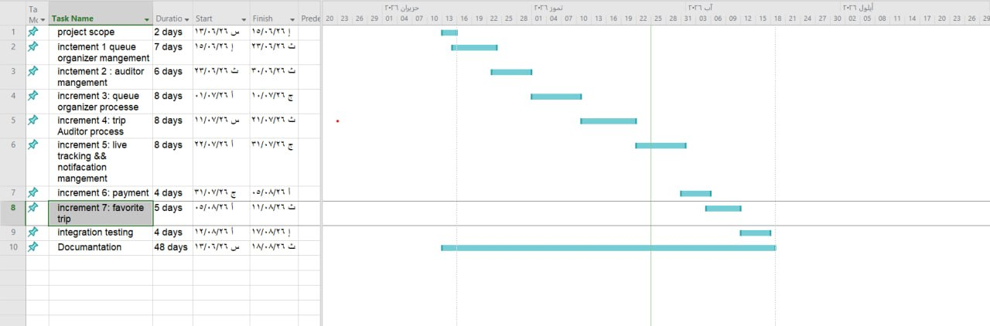

6-Project charter
Project title | Public transport launch center management system
Project start date | 13/10/2026
Project finish date | 15/1/2027
Project manger  Project objectives | Automating and developing transportation and public transit processes in order to manage transport lines and work on organizing the operations conducted at the transport center (garage)
Approach | 1- Define the project scope and objectives.  2- Accurately analyze the system specifications and requirements.  3- Design and analyze the system architecture.  4- Develop the first phase with a focus on access permissions.  5- Test the functions of the first phase and verify its permissions.  6- Second phase: Integrate the system with the state's systems and institutions.  7- Conduct tests on the second phase.  8- Document all phases and their results.
Table 1 project charter
Table 2 project charter

7-Roles and Responsibilities
Name | Rule | Responsibilities
Eng.Rania Rajab | supervisor | Highly project management
Mohamad Al Nasser | Developer | Back end and tester
Mohamad Al Nasser | Developer | Analyst and front end
Table 3 responsibilities

8- Risk management
Risk ID | Risk Description | Related FRs | Probability | Impact | Risk Level | Mitigation Strategy
R-01 | Live Tracking Failure / Delay: Disconnection of internet or GPS accuracy issues affecting real-time bus location. | FR19 | Medium | High | High | Implement lightweight and fast protocols (e.g., WebSockets/MQTT). Enable local data caching on the bus device during temporary network loss.
R-02 | Authorization Leaks: A user (e.g., Queue Organizer) bypassing roles to modify another user's data or access unauthorized manager features. | FR1 - FR12 | Low | High | High | Implement a strict Role-Based Access Control (RBAC) system. Encrypt and validate secure tokens (e.g., JWT) on every API request.
R-03 | Race Conditions in Queue Modification: Multiple organizers attempting to modify or reorder the same queue simultaneously. | FR10, FR11 | Medium | Medium | Medium | Apply Optimistic Locking mechanism in the database to prevent conflicting concurrent updates.
R-04 | Notification Delivery Failure: Critical complaints or turn-skipping alerts get delayed or lost before reaching the manager. | FR13, FR14, FR20, FR21 | Medium | Medium | Medium | Use reliable cloud notification services (e.g., Firebase Cloud Messaging) backed by a robust background job queuing system.
Table 4 risk management

9- Project Quality Management
To ensure the delivery of a highly reliable software product, the following procedures were adopted:
* Code Review: Periodically reviewing the code to ensure it follows best practices (Clean Code).
* Preliminary Testing: Conducting unit tests for the software logic related to route calculations and bus definitions.
* Acceptance Criteria: Defining precise criteria for each feature before considering it "completed" to ensure it is free of logical errors.
Project Management Tools Used
A set of digital tools was relied upon to organize workflow and document tasks:
* GitHub Projects: to manage programming tasks.
* Excel: To manage project Schedule "Gantt Chart".

Chapter3 Reference study

1.For the field study and stakeholder analysis,
the process of system requirements elicitation relies on a hybrid engineering methodology that combines theoretical study of software sources with analytical field interviews (Structured Interviews) with direct stakeholders at the Directorate of Transportation in Damascus Governorate and the officials responsible for managing the Southern Region Departure Center (Daraa Garage). This study aims to identify operational gaps in the current situation and transform them into intelligent software requirements.
1. Interview Profile
The following table summarizes the documentation data of the field interview conducted:
Element | Details
Target entity | Directorate of Transport in Damascus Governorate - Southern Zone Departure Center Management (Daraa Garage)
Job title of the respondent: | Organizer responsible for managing and coordinating the queue bus .
Interview methodology | : Structured Face-to-Face Interview
Primary objective: | Elicit system requirements, identify operational problems, and determine user (actor) permissions.
Table 5 intreview profile
2. Interview Themes & Problem Identification
The current operational situation of the garage was discussed, and the main issues were inventoried and classified technically as follows:
1- Randomness in bus queue management: Bus departure roles are coordinated on paper or manually at the 'Garage Gate,' causing role overlaps and overtaking problems due to the absence of an immediate digital tracking system.
2- Gaps in booking and the black market: The center lacks a digital documentation mechanism for passenger names, allowing brokers to manipulate ticket prices during peak times (such as Sunday morning and Thursday afternoon).
3- Loss of complaint linkage: Complaints are currently submitted via a slow paper process, leading to neglect of citizens' complaints and failure to link violations (such as overcharging) automatically to the driver or trip.
4- Environmental and local constraints: The importance of system stability and data synchronization under network or power outages (Fault Tolerance) was noted.
3. Stakeholders & Actors Identification
Based on the functional analysis of the interview, the final structure of users interacting with the system was determined, confirming the need for role-based access control:
1- Garage Manager: Holds top privileges to monitor the fleet, handle complaints, and suspend violators.
- Terminal Dispatcher (Actor created based on the interview): Physically responsible for entering queued buses and verifying tickets at the gates.
2- Driver: User with an interface to view assigned trips and update route status.
3- Citizen: User who can view trips, book seats, and submit complaints linked to a digital ID number.
4. Architectural Impact
This interview directly contributed to formulating the Requirements Traceability Matrix (RTM); pre-conditions for each microservice were established based on the garage's regulatory rules, such as preventing the scheduling of an unavailable bus or requiring an official management response to close complaints programmatically.

Similar applications
"Five leading transportation platforms were selected: three global systems focusing on public transit and navigation, and two regional/global applications focusing on on-demand private ride-hailing."

- Lyft
- Carem
- Moovit
- Transit App
- Citymapper

1.1-Lyft
offering the following features:
1. Individual transportation service that provides private cars to transport individuals from their location to their destination quickly and easily.
2. Shared ride service that allows users to share the ride with other passengers, reducing the cost.
3. Provides larger cars that accommodate more passengers, ideal for families or groups.
4.
1.2-Careem
1. Diverse Services: It offers a variety of services, including transportation services.
2. Transportation Service: It provides private cars for transporting individuals, in addition to options such as Careem GO and Careem XL for groups.
3. Fast Delivery: It offers the Careem NOW service, which allows food to be delivered quickly from restaurants to homes.
1.3-Moovit
1. A global app that provides trip planning.
2. Supports real-time bus tracking.
3. Provides text and audio data for the stations.
4. Relies on artificial intelligence algorithms to reduce waiting time.
1.4-Transit App
1. An app that provides maps and transportation routes
2. Supports real-time notifications for line changes
3. Offers estimated arrival times
4. Used by millions of users in Europe and America
1.5-CityMapper
1. Supports trip planning by integrating more than one mode of transport (bus - microbus - metro)
2. Interactive user interface
3. Comparison of time and cost between transportation options
4. Provides usage reports

3.Modern technologies and frameworks in the field
The field of distributed software system development and intelligent transportation management witnesses significant reliance on frameworks and technical architectures that ensure high efficiency, scalability, and service independence. In this project, the most prominent of these modern technologies were employed:
.NET 8 Environment: The latest framework from Microsoft for building advanced backend services, characterized by high performance, strong security, and full support for building Web APIs.
Microservices Architecture: The modern approach in building large systems by dividing the application into small, independent services that are easy to maintain and develop, instead of traditional monolithic systems.
React Framework: One of the most popular frontend frameworks for developing interactive, responsive user interfaces, relying on reusable components.
Docker Containers Technology: The modern standard environment for packaging software services and ensuring their consistent and stable operation across different operating systems (Windows, Linux), facilitating deployment and instant updates.
Ocelot API Gateway: A modern tool for securing a unified entry point for all user requests, intelligently routing them to the required microservice while handling security and digital verification.
4-Theoretical Framework and Reference Studies (Theoretical Framework)
The project relies in its computational and engineering structure on a set of well-established theories and scientific principles in software engineering:
Microservices & API Gateway Architecture: A computational theory that relies on dividing complex systems into completely independent and loosely coupled units, with requests directed to them through a single entry point (Ocelot) to manage routing and security centrally.
Clean Architecture Principles: An engineering theory that relies on the separation of concerns through circular layers, where the core business logic is at the center, completely isolated and independent from databases or external frameworks.
Digital Security Principles (JWT & Cryptography Authentication): Relying on the stateless token protocol based on cryptography to verify user identities and their roles without overloading the server.
Database-per-Service Pattern: A database design theory that ensures data non-interference and independence, where each service has a completely isolated SQL Server database.
5. Modern and Future Directions in the Field (Future Trends in the Field)
This project aligns with modern global trends and can be developed in the future to integrate with the following emerging technologies:
Edge AI & IoT: To process data from bus sensors and track their arrival and departure times instantly on the "edge" without consuming internet packages, which improves the accuracy of trip schedules.
MLOps: To build and deploy predictive models that anticipate peak times and passenger congestion at the terminal based on historical trip and seasonal data, and continuously and automatically update these models.

Chapter 4 :

Analytical

study

2-Requirements Elicitation
We carried out the process of deriving the project requirements through the theoretical study of the project, as well as through repeated meetings with the stakeholders (Daraa Garage Manager) and the assistance of our supervisor. The requirements were also derived and collected through the help of studying similar projects.

3-stakeholders
- Bus Drivers :responsible for updating trip ,status , completing routes, and repor ting issues during transit .
- Garage manager :manages drivers , buses , routes ,trips ,and handles
Citizen complaints and and operations .
- Passengers : citizens who book tickets , track trips , view schedules, and submit complaints
- Queue organizer : employee can organize queue order bus
- Trip auditor : trip Auditor who chick ticket

4-functctional requirements
ID | Title
FR1 | Garage manger can add new Queue organizer
FR2 | Garage manger can update Queue organizer
FR3 | Garage manger can delete Queue organizer
FR4 | Garage manger can show Queue organizer
FR5 | Garage manger can add new Auditor
FR6 | Garage manger can update information Auditor
FR7 | Garage manger can delete Auditor
FR8 | Garage manger can show Auditor
FR9 | Queue organizer can add bus to queue
FR10 | Queue organizer can modify the queue order
FR11 | Queue organizer can delete bus in queue order
FR12 | Queue organizer can show queue
FR13 | Queue organizer can send(submit) complaints
FR14 | Queue organizer can submit a violate to driver who break roles.
FR15 | Trip Auditor can show trip should audit
FR16 | Trip Auditor can select trip to audit
FR17 | Trip auditor can audit trip
FR18 | Trip Auditor can show trip audit history
FR19 | All users can live tracking bus
FR20 | all actor can show notification
FR21 | all actors can make notifications as read
FR22 | Citizen can add favorite trip
FR23 | Citizen can delete trip in favorite list
FR24 | Citizen can show list favorite trip
FR25 | Citizen and Driver can set a reminder for their trips
FR26 | Citizen and Driver can unset a reminder for their trips
FR27 | Citizen can pay with his Strip card to confirm booking

Table 6 function requirments

5-Nonfunctional requirement
Nonfunctional requirement
Security | Authentication using username and password with encryption of user data using a hash algorithm  Implementing permission granting in the authorization system
Performance | The system response time must not exceed 2 seconds when executing basic operations.
Usability | The system interfaces must be simple. The user should be able to complete basic operations (such as booking a trip) easily without training. The system should be usable across different devices (computer, tablet, mobile).
Availability | The system must maintain operational readiness to ensure continuous availability of system services.
Table 7 nonfunctional requirement

6-Prioritization of requirements and the mechanism for their management
ID | Requirement Name | Description | Actor(s) | MoSCoW | Justification
1 | Queue organizer Management | Manage organizer (add, edit, delete, search) | Garage Manager | Must | Core system functionality
2 | Auditor Management | Manage auditor (add, edit, delete, search) | Garage Manager | Must | Essential for operations
3 | Queue mange | Manage queue ( add ,update ,delete , show ) | Queue Organizer | Must | Required for service delivery
4 | Trip Auditor Manage | Auditing process (select trip, show trip, auditing trip,) | Auditor | Must | Critical for user interaction
5 | Live tracking | Bus view and tracking in real time | Garage manger&&citizen | Should | Improves user experience
6 | Notification  Management | Notification show and make it as read | All Actors | Should | Useful but not critical
7 | Favorite trip | trip can be favorite (add, delete ,show ) | Citizen | Could | Enhancement feature
9 | Mobile Application | Mobile version of the system | - | Won’t | Outside the scope of the current project
Table 8 MOSCOW

7-system description of features(High level use case diagram)
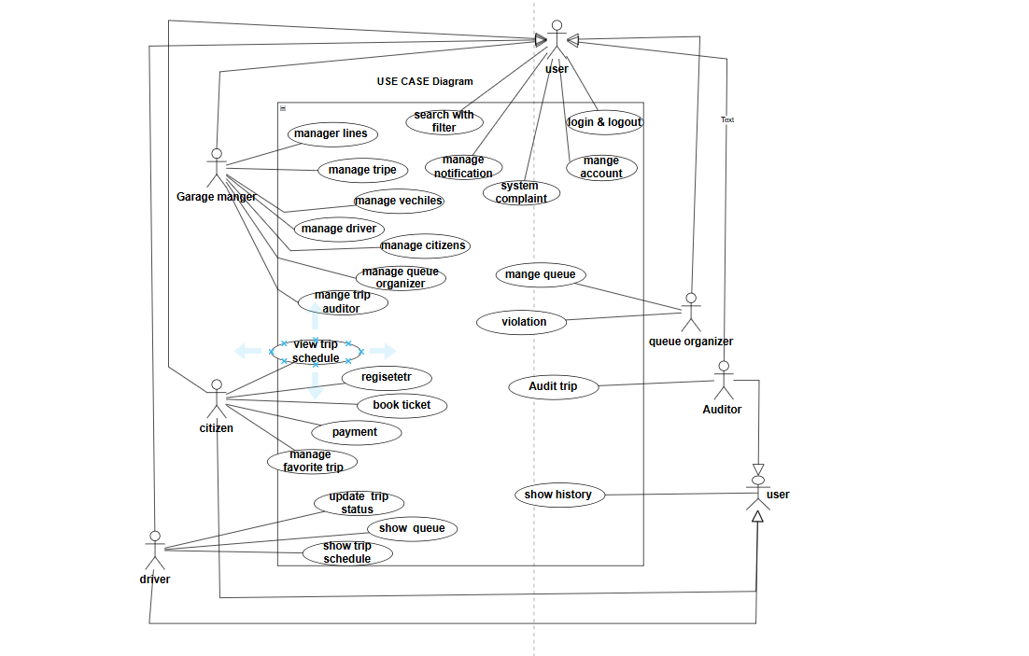
Figure 1 use case high level

7-1-Main Use Case Diagrams
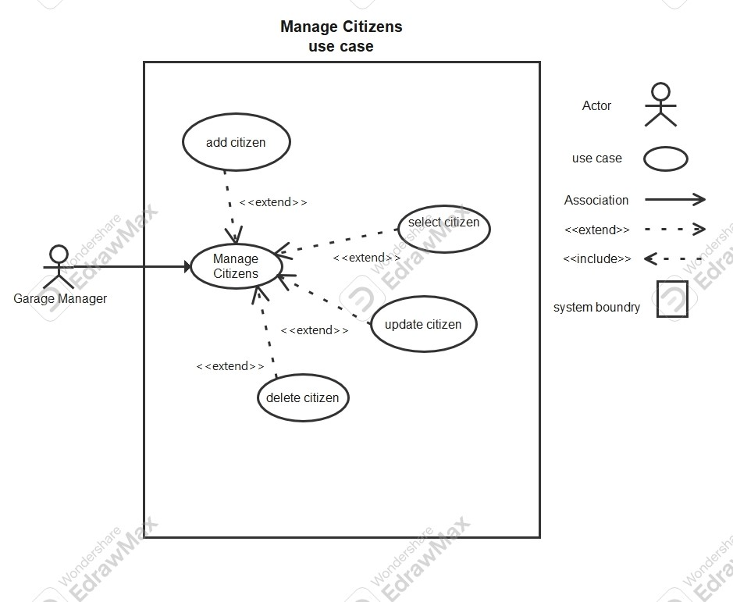
Table 9 use case mange citizens

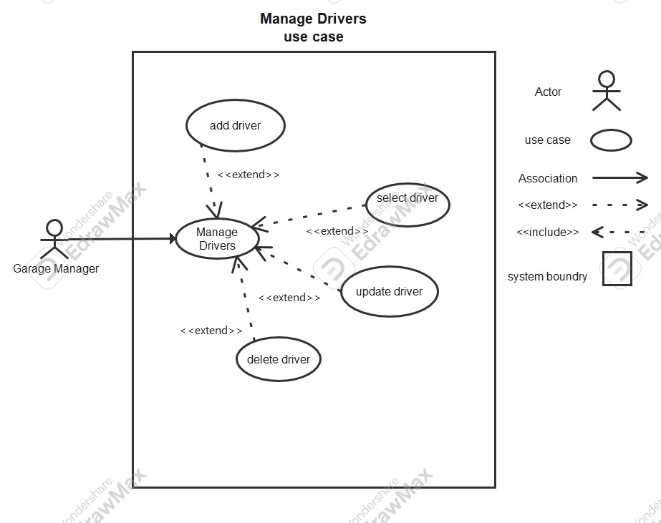
Table 10 use case mange drivers
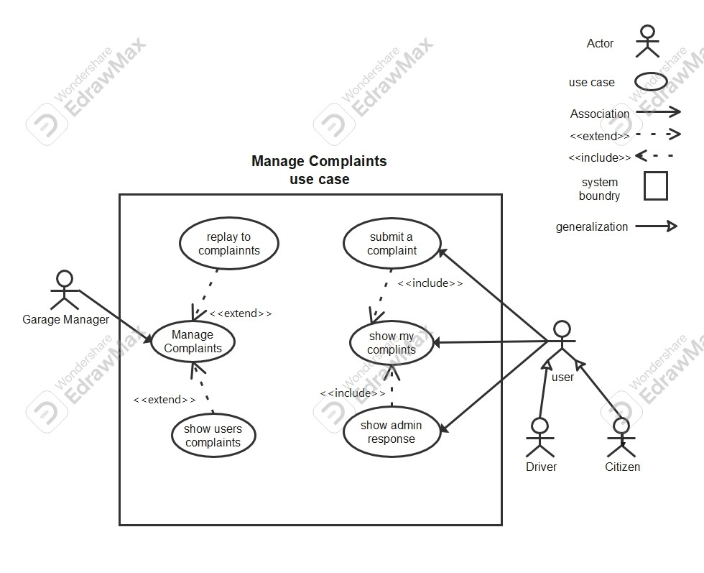
Table 11 use case mange complaints

87-2- use case Descriptions

Field | Description
Use Case ID | UC-01
Name | Add queue organizer
Actor(s) | Garage Manager
Preconditions | - User is logged into the system  - Dashboard is loaded- User is on "Manage queue organizer" page
Postconditions | - New driver is created and stored in the system  - OR Error message is displayed
Main Flow | - User clicks "New organizer"  - System displays organizer form  - User enters required information  - User clicks "Create organizer"  - System validates data  - System saves driver  - 9. System displays success message: "Driver created successfully"
Alternative Flow | A1: Cancel Operation  - User clicks "Cancel"- System returns to Manage Drivers page  A2: Validation Error  - Invalid or duplicate data (e.g., email exists)  - System displays error message (e.g., "Email already in use")
Table 12 description uc-01

Field | Description
Use Case ID | UC-02
Name | Update Manager
Actor(s) | Garage Manager
Preconditions | - User is logged in  - User is on "Manage queue organizer "page  - Driver already exists
Postconditions | - organizer information is updated OR  - No changes are made
Main Flow | - User click "Edit "  - System display form  - User modifies organizer information:  - User clicks "Update organizer"  - System asks for confirmation  - User confirms update  - System saves changes  - 8 System displays: "Driver updated successfully"
Alternative Flow | A1: Cancel Update  - User clicks "Cancel"- System discards changes  A2: Validation Error- Invalid data entered  - System shows error message  A3: User Rejects Confirmation  - User cancels confirmation dialog- No update occurs
Table 13 description

Field
Use Case ID | UC-03
Name | Delete organizer
Actor(s) | Garage Manager
Preconditions | - User is logged in  - User is on Manage Drivers page  - organizer exists
Postconditions | - organizer is deleted from the system OR  - organizer remains unchanged
Main Flow | 1. User clicks "Delete" on a organizer  2. System displays confirmation message :"Are you sure you want to delete this organizer?"  3. User clicks "Delete"  4. System removes driver from database  5. System displays: "Driver deleted successfully"
Alternative Flow | A1: Cancel Delete  - User clicks "Cancel"  - System keeps driver unchanged  A2: Error During Deletion  - System fails to delete driver  - System displays error message
Table 14 descirption UC-03
Field | Description
Use Case ID | UC-04
Name | Show organizer Details
Actor(s) | Garage Manager
Preconditions | - User is logged in organizer  - User is on Manage Drivers page  - Driver exists
Postconditions | - Driver details are displayed
Main Flow | 1. User clicks "Show Details" on a organizer  2. System navigates to driver details page  3. System displays full driver information
Alternative Flow | A1: Driver Not Found  - Driver does not exist  - System displays error message
Table 15 descirption UC-04
Field | Description
Use Case ID | UC-05
Name | Add Auditor
Actor(s) | Garage Manager
Preconditions | - User is logged into the system  - Dashboard is loaded  - User is on "Manage Auditor" page
Postconditions | - New vehicle is added to the system OR  - Error message is displayed
Main Flow | - User clicks "New Auditor"  - System displays Auditor form  - User enters Auditor information: ,  - User clicks "Create Auditor"  - System validates input  - System saves Auditor  - System displays success message: "Auditor created successfully"
Alternative Flow | A1: Cancel Operation  - User clicks "Cancel"  - System returns to Manage Auditor page  A2: Validation Error  - Invalid or duplicate data (e.g., email exists)  - System displays error message
Table 16 descirption UC-05
Field | Description
Use Case ID | UC-06
Name | Update Auditor
Actor(s) | Garage Manager
Preconditions | - User is logged in  - User is on Manage Auditor page  - Auditor exists
Postconditions | - Auditor information is updated OR  - No changes are made
Main Flow | . User updates Auditor information:  4. User clicks "Update Auditor"  5. System displays confirmation message :"Confirm Update: Are you sure you want to update this Auditor?"  6. User clicks "Update"  7. System saves changes  8. System displays: "Auditor updated successfully"
Alternative Flow | A1: Cancel Delete  - User clicks "Cancel"  - System keeps Auditor unchanged  A2: Error During Deletion  - System fails to delete Auditor  - System displays error message
Table 17 descirption UC-06
Field | Description
Use Case ID | UC-07
Name | Delete Auditor
Actor(s) | Garage Manager
Preconditions | - User is logged in  - User is on Manage Auditor page  - Vehicle exists
Postconditions | - Auditor is deleted from the system OR  - Auditor remains unchanged
Main Flow | 1. User clicks "Delete" on a Auditor  2. System displays confirmation message:"Confirm Delete: Are you sure you want to delete this Auditor?"  3. User clicks "Delete"  4. System removes vehicle from database  5. System displays: "Auditor deleted successfully"
Alternative Flow | A1: Cancel Delete  - User clicks "Cancel"  - System keeps Auditor unchanged  A2: Error During Deletion  - System fails to delete Auditor  - System displays error message
Table 18 uc-07

Field | Description
Use Case ID | UC-08
Name | Show Auditor Details
Actor(s) | Garage Manager
Preconditions | - User is logged in  - User is on Manage Auditor page  - Vehicle exists
Postconditions | - Auditor details are displayed
Main Flow | 1. User clicks "Show Details" on a Auditor  2. System navigates to vehicle details page  3. System displays full vehicle information
Alternative Flow | A1: Auditor Not Found  - Auditor does not exist  - System displays error message
Table 19 uc-08
Field | Description
Use Case ID | UC-09
Name | Add bus on queue lest
Actor(s) | Queue Organizer
Preconditions | - User is logged into the system  - Dashboard is loaded  - User is on "Manage queue " page
Postconditions | - New bus is created and stored in the queue OR  - Error message is displayed
Main Flow | 1. User clicks "Manage queue"  2. System displays queue management page  3. User clicks "New bus"  4. System displays bus form  5. User enters required information:  6. User clicks "add bus "  7. System validates input  8. System saves data  9. System displays: "bus added successfully"
Alternative Flow | A1: Cancel Operation  - User clicks "Cancel"- System returns to queue management page  A2: Validation Error  - Invalid or duplicate data (bus number plant or invalid data)- System displays error message
Table 20 uc-09

Field | Description
Use Case ID | UC-10
Name | Update queue
Actor(s) | Queue organizer
Preconditions | - User is logged in  - User is on Manage Users page  - bus exists
Postconditions | - queue information is updated OR  - No changes are made
Main Flow | 1. User clicks "Edit" on a queue  2. System displays edit form with existing data  3. User updates queue information  4. User clicks "Update queue"  5. System displays confirmation message :"Confirm Update: Are you sure you want to update this queue?"  6. User clicks "Update"  7. System saves changes  8. System displays: "queue updated successfully"
Alternative Flow | A1: Cancel Update  - User clicks "Cancel"- System discards changes  A2: Validation Error  - Invalid data entered- System displays error message  A3: Cancel Confirmation  - User cancels confirmation dialog- No update occurs
Table 21 uc-10
Field | Description
Use Case ID | UC-11
Name | Delete Vehicle from queue
Actor(s) | Queue organizer
Preconditions | - User is logged in  - User is on Manage Users page  - bus exists
Postconditions | - bus deleted from the queue OR  - Citizen remains unchanged
Main Flow | 1. User clicks "Delete" on a bus  2. System displays confirmation message:"Confirm Delete: Are you sure you want to delete this bus from queue ?"  3. User clicks "Delete"  4. System removes bus from database  5. System displays: "Citizen deleted successfully"
Alternative Flow | A1: Cancel Delete  - User clicks "Cancel"  - System keeps queue unchanged  A2: Error During Deletion  - System fails to delete queue  - System displays error message
Table 22 uc-11
Field | Description
Use Case ID | UC-12
Name | Show queue Details
Actor(s) | Queue organizer
Preconditions | - User is logged in  - User is on Manage queue page  - bus exists
Postconditions | - queue details are displayed
Main Flow | 1. User clicks "Show Details" on a queue  2. System navigates to queue details page  3. System displays full queue information
Alternative Flow | A1: bus Not Found in queue  - bus does not exist  - System displays error message
Table 23 uc-12
Field | Description
Use Case ID | UC-13
Name | Submit complaint
Actor(s) | Queue organizer
Preconditions | - User is logged into the system  - Dashboard is loaded
Postconditions | - Complaint is stored in the system with status "Pending"
Main Flow | 1. User clicks "Complaints" from dashboard  2. System displays complaint form  3. User enters: - Subject - Description  4. User clicks "Submit Complaint"  5. System validates input  6. System saves complaint with status "Pending"  7. System displays message: "Complaint submitted successfully"  8. System displays the complaint under "My Complaints"
Alternative Flow | A1: Cancel Operation  - User leaves the page or cancels- No complaint is submitted  A2: Validation Error  - Missing required fields- System displays error message
Table 24 uc-13

7-3-Activity Diagrams 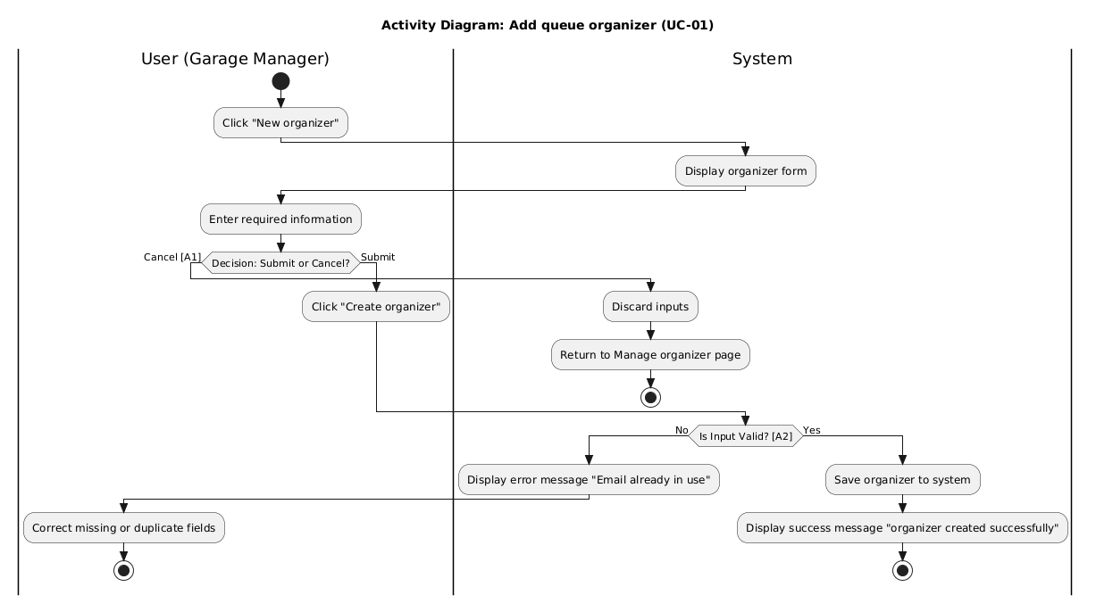Figure 2 Activity uc-0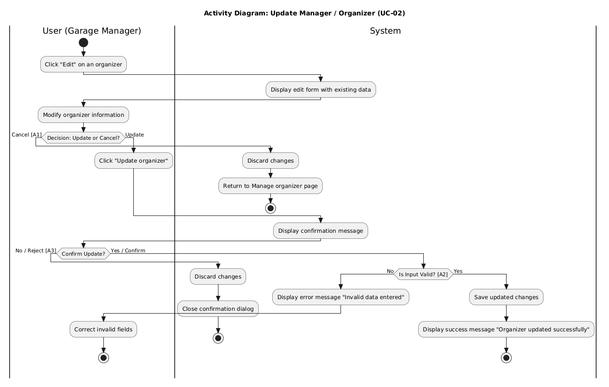Figure 3 activity uc-02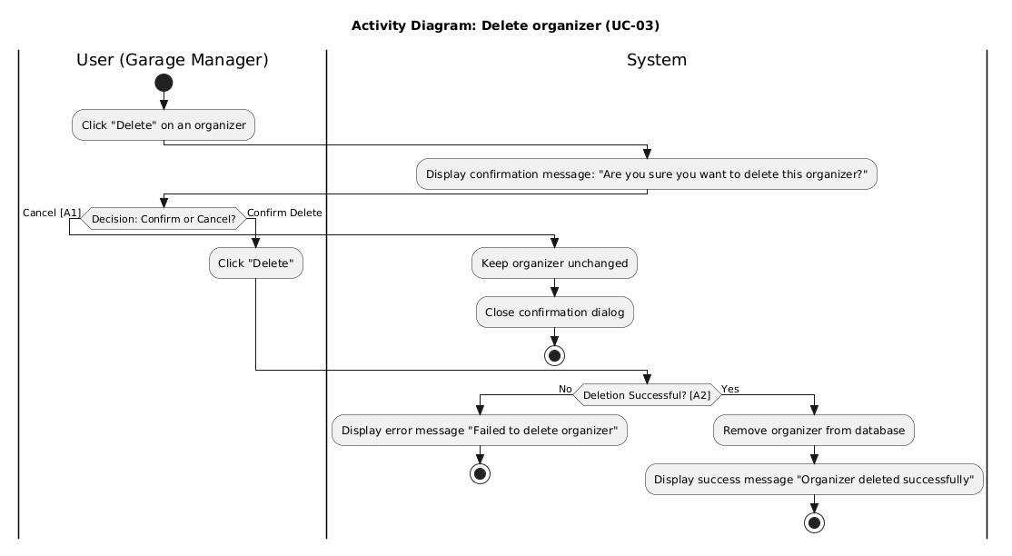
Figure 4 Activity uc-03
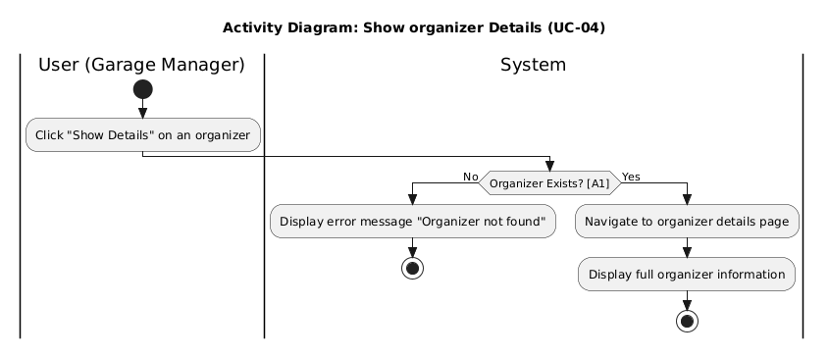
Figure 5 activity uc-04

7-4-Sequence Diagrams
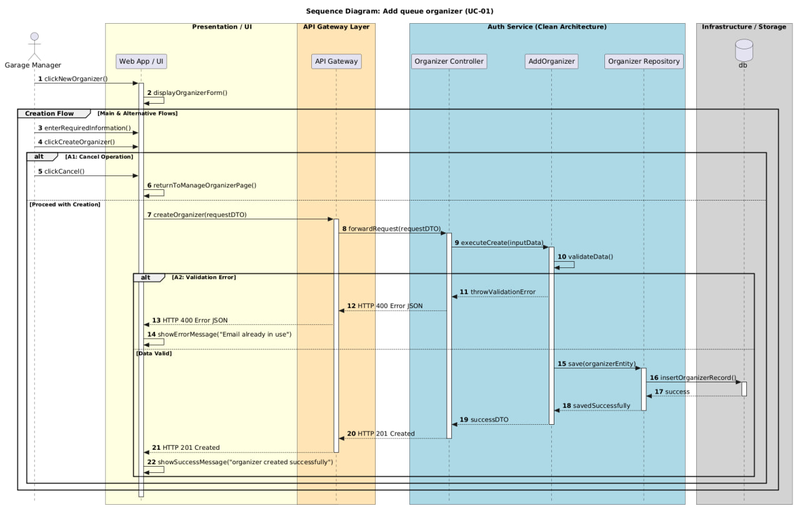 Figure 6 sequence UC-1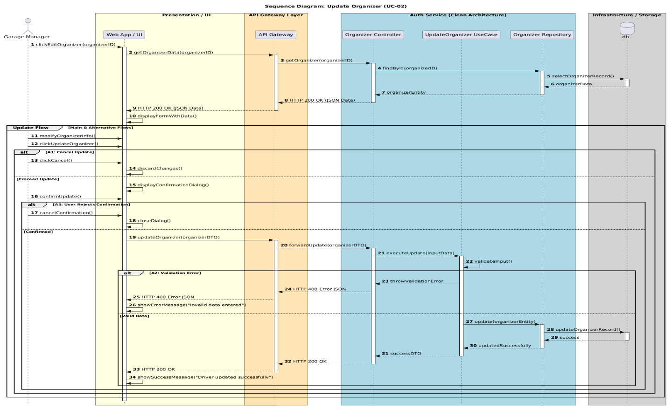Figure 7 sequence UC-02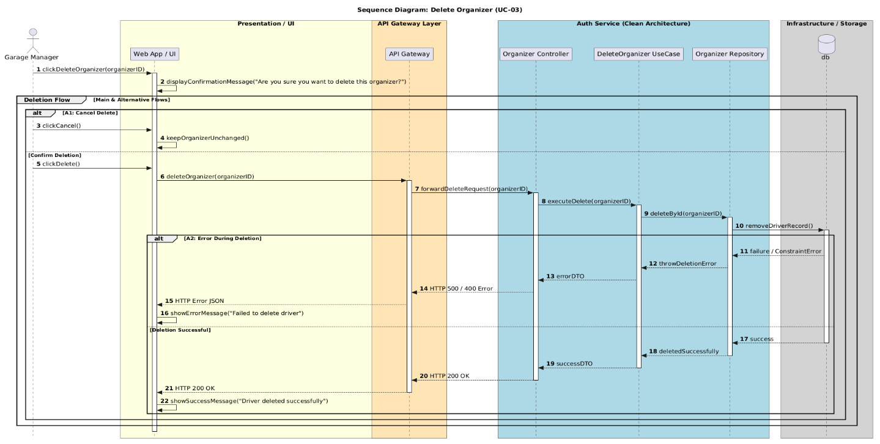Figure 8 sequence uc0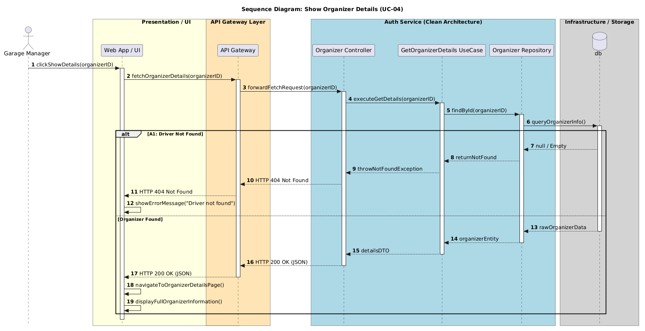Figure 9 sequnce UC-04

7-5-Requirements Traceability Matrix
ID | Requirement Title | Dependencies | SRS Section | Design Section | Coding | Test Case ID | Acceptance Criteria
FR1 | Garage manager can add new Queue organizer | None | UC-01 (Table 12) | Architectural Design | backend/userService/userService.Api | TC-01 / TC-02 / TC-03 | تعبئة البيانات الأساسية وإنشاء حساب المنظم بنجاح.
FR2 | Garage manager can update Queue organizer | FR1 | UC-02 (Table 13) | Architectural Design | backend/userService/userService.Api | TC-04 / TC-05 / TC-06 | تحديث معلومات المنظم دون تضارب مع الحسابات الأخرى.
FR3 | Garage manager can delete Queue organizer | FR1 | UC-03 (Table 14) | Architectural Design | backend/userService/userService.Api | TC-07 / TC-08 / TC-09 | ألا يكون المنظم مرتبطاً بطابور نشط أو رحلة جارية.
FR4 | Garage manager can show Queue organizer | FR1 | UC-04 (Table 15) | Architectural Design | backend/userService/userService.Api | TC-10 / TC-11 / TC-12 | استعراض كافة المنظمين المتاحين في الكراج بوضوح.
FR5 | Garage manager can add new Auditor | None | UC-05 (Table 16) | Architectural Design | backend/userService/userService.Api | TC-13 / TC-14 / TC-15 | إسناد دور (Auditor) وتفعيل صلاحيات تدقيق الرحلات.
FR6 | Garage manager can update information Auditor | FR5 | UC-06 (Table 17) | 5.3. Architectural Design | backend/userService/userService.Api | TC-16 / TC-17 / TC-18 | تحديث البيانات بنجاح مع عدم المساس بسجلات التدقيق التاريخية.
FR7 | Garage manager can delete Auditor | FR5 | UC-07 (Table 18) | Architectural Design | backend/userService/userService.Api | TC-19 / TC-20 / TC-21 | اعتماد الحذف الناعم (Soft Delete) لضمان سلامة السجلات.
FR8 | Garage manager can show Auditor | FR5 | UC-08 (Table 19) | Architectural Design | backend/userService/userService.Api | TC-22 / TC-23 / TC-24 | عرض تفاصيل وقائمة كافة المدققين المعتمدين.
FR9 | Queue organizer can add bus to queue | None | UC-09 (Table 20) | Architectural Design | backend/organizerService | Section 8.2.1 | إضافة الحافلة للطابور بشرط عدم تواجدها في طابور نشط آخر.
FR10 | Queue organizer can modify the queue order | FR9 | UC-10 (Table 21) | Architectural Design | backend/organizerService | Section 8.2.1 | إمكانية تغيير وترتيب أدوار الحافلات داخل الطابور.
FR11 | Queue organizer can delete bus in queue order | FR9 | UC-11 (Table 22) | Architectural Design | backend/organizerService | Section 8.2.1 | إزالة الحافلة وإعادة ترتيب الحافلات المتبقية تلقائياً.
FR12 | Queue organizer can show queue | FR9 | UC-12 (Table 23) | Architectural Design | backend/organizerService | Section 8.2.1 | عرض تسلسل وحالة الحافلات في الطابور الحالي بشكل لحظي.
FR13 | Queue organizer can send complaints | None | UC-13 (Table 24) | Architectural Design | backend/organizerService | Table 8.2.1.5 | تسجيل الشكوى وحفظها بحالة (Pending) لإدارة المجمع.
FR14 | Queue organizer can submit a violate to driver who break roles | None | UC-14 (Table 25) | Architectural Design | backend/organizerService | Table 8.2.1.5 | ربط المخالفة بالسائق/الحافلة وتوثيق نوع المخالفة.
FR15 | Trip Auditor can show trip should audit | None | Chapter 4 Analysis | Architectural Design | backend/auditService | Section 8.2.1 | استعراض كافة الرحلات المكتملة التي تتطلب تدقيقاً مالياً/إدارياً.
FR16 | Trip Auditor can select trip to audit | FR15 | Chapter 4 Analysis | Architectural Design | backend/auditService | Section 8.2.1 | قفل الرحلة المختارة وتعيينها للمدقق للبدء بمراجعتها.
FR17 | Trip auditor can audit trip | FR16 | Chapter 4 Analysis | Architectural Design | backend/auditService | Section 8.2.1 | اعتماد الحسابات المالية للرحلة أو تسجيل الملاحظات عليها.
FR18 | Trip Auditor can show trip audit history | FR17 | Chapter 4 Analysis | Architectural Design | backend/auditService | Section 8.2.1 | عرض أرشيف الرحلات التي تم تدقيقها سابقاً مع التفاصيل.
FR19 | All users can live tracking bus | None | Chapter 4 Analysis | Architectural Design | backend/ livetracking Service | Section 8.2.1 | التتبع الحي لموقع الحافلة على الخريطة ببيانات لحظية.
FR20 | All actor can show notification | None | Chapter 4 Analysis | Architectural Design | backend/NotificationService | Section 8.2.1 | عرض قائمة الإشعارات الواردة لكل مستخدم حسب دوره.
FR21 | All actors can make notifications | FR20 | Chapter 4 Analysis | Architectural Design | backend/NotificationService | Section 8.2.1 | تحديث حالة الإشعار إلى "مقروء" (Read).
FR22 | Citizen can add favorite trip | None | Chapter 4 Analysis | Architectural Design | Frontend/api.js | Section 8.2.1 | حفظ الرحلة أو المسار ضمن قائمة المفضلات الخاصة بالموارد.
FR23 | Citizen can delete trip in favorite list | FR22 | Chapter 4 Analysis | Architectural Design | Frontend/api.js | Section 8.2.1 | إزالة الرحلة من قائمة المفضلات بنجاح.
FR24 | Citizen can show list favorite trip | FR22 | Chapter 4 Analysis | Architectural Design | Frontend/api.js | Section 8.2.1 | استعراض جميع الرحلات المضافة للمفضلة بدقة.
FR25 | Citizen and Driver can set a reminder for their trips | None | Chapter 4 Analysis | Architectural Design | backend/NotificationService | Section 8.2.1 | تفعيل تنبيه مخصص قبل موعد موعد انطلاق الرحلة.
FR26 | Citizen and Driver can unset a reminder for their trips | FR25 | Chapter 4 Analysis | Architectural Design | backend/NotificationService | Section 8.2.1 | إلغاء التنبيه المكتوب سابقاً بدون أخطاء.
FR27 | Citizen can pay with his Stripe card to confirm booking | None | Chapter 4 Analysis | Architectural Design | backend/paymentServicei | Section 8.2.1 | المعالجة الناجحة لعملية الدفع الإلكتروني بـ Stripe وتأكيد الحجز.

7-6-Test Case Descriptions
Test ID | Req ID | Test Type | Test Case Title | Test Steps | Expected Result
TC-01 | FR1 | Positive | Add Queue Organizer with valid complete data | 1. Log in as Garage Manager.  2. Fill in all required fields correctly.  3. Click 'Save'. | Queue Organizer is saved successfully, appears in the list, and can log in to the system.
TC-02 | FR1 | Negative | Add Queue Organizer with missing required fields | 1. Leave name or email empty.  2. Click 'Save'. | Validation error message appears requesting required fields; data is not saved.
TC-03 | FR1 | Negative | Add Queue Organizer with already existing email | 1. Enter an email address that already exists in the system.  2. Click 'Save'. | Error message appears: 'Email already in use'; operation fails.
TC-04 | FR2 | Positive | Update Queue Organizer name and phone number successfully | 1. Select an existing Queue Organizer.  2. Modify name and phone number.  3. Click 'Update'. | Information updated successfully and new details display in the list.
TC-05 | FR2 | Negative | Update Queue Organizer with invalid email format | 1. Change email to an invalid format (e.g., user@com).  2. Click 'Update'. | System rejects the update and displays an invalid email format warning.
TC-06 | FR2 | Negative | Cancel update operation without saving | 1. Modify some fields.  2. Click 'Cancel' or close the window. | Original data remains unchanged without saving modifications.
TC-07 | FR3 | Positive | Delete Queue Organizer with confirmation | 1. Click 'Delete' next to a Queue Organizer.  2. Confirm deletion in the popup prompt. | Organizer is completely removed from the list and login access is revoked.
TC-08 | FR3 | Edge Case | Cancel deletion prompt for Queue Organizer | 1. Click 'Delete' next to a Queue Organizer.  2. Select 'Cancel' in the confirmation prompt. | Deletion process stops and the organizer remains in the list.
TC-09 | FR3 | Negative | Delete Queue Organizer assigned to an active queue | 1. Attempt to delete an organizer currently managing an active queue. | Deletion blocked with message: 'Cannot delete organizer managing an active queue'.
TC-10 | FR4 | Positive | View full list of all Queue Organizers | 1. Navigate to 'Show Queue Organizers' view. | Complete list of all registered Queue Organizers is rendered with basic details.
TC-11 | FR4 | Edge Case | View list when no Queue Organizers exist | 1. Access the view when no organizers are registered in the system. | Clear message displays: 'No Queue Organizers found'.
TC-12 | FR4 | Positive | Search/filter within Queue Organizers list | 1. Enter a specific organizer name into the search bar. | List dynamically updates to display only matching search results.
TC-13 | FR5 | Positive | Add new Trip Auditor with valid information | 1. Navigate to 'Add Auditor' page.  2. Enter valid details.  3. Click 'Save'. | New Auditor account created successfully and confirmation displayed.
TC-14 | FR5 | Negative | Add Auditor with a weak password | 1. Enter a password below minimum length (e.g., < 6 chars).  2. Click 'Save'. | Error message requires a stronger password; creation fails.
TC-15 | FR5 | Negative | Add Auditor without selecting assigned role/permissions | 1. Leave role selection empty.  2. Click 'Save'. | System prompts user to select a valid role before proceeding.
TC-16 | FR6 | Positive | Update Auditor details and permissions successfully | 1. Select an Auditor.  2. Modify assigned audit section/details.  3. Save. | Auditor information and permissions updated successfully.
TC-17 | FR6 | Negative | Update non-existent Auditor (deleted concurrently) | 1. Attempt saving edits for an Auditor removed in another session. | Error message: 'Auditor not found or already modified'.
TC-18 | FR6 | Positive | Reset password for an Auditor account | 1. Select Auditor and click 'Reset Password'.  2. Input new password & confirm. | Password updated successfully; Auditor can log in with new credentials.
TC-19 | FR7 | Positive | Delete Auditor with confirmation | 1. Select Auditor from list.  2. Click 'Delete' and confirm. | Auditor removed from list and account access revoked.
TC-20 | FR7 | Negative | Delete Auditor with pending assigned trip audits | 1. Select an Auditor with active/pending audit assignments.  2. Confirm delete. | System blocks deletion until pending audits are reassigned.
TC-21 | FR7 | Edge Case | Verify soft deletion retains historical audit logs | 1. Delete Auditor.  2. Inspect past audited trip records. | Auditor removed from active list, but past audit logs retain original Auditor name.
Table 26 test case

Chapter 5

Architectural Design

5.1 System Architectural Design
The Bus Station Management and Tracking System relies on a sophisticated, multi-tiered architectural pattern that ensures full Separation of Concerns, Scalability, and Maintainability. The system is built upon three integrated architectural tiers:
[ Front-End Clients (Mobile / Web) ]
│
▼ (HTTP / HTTPS / WebSockets)
┌─────────────────┐
│ API Gateway │
└────────┬────────┘
│
┌────────────┼────────────┬────────────┐
▼ ▼ ▼ ▼
┌────────┐ ┌────────┐ ┌────────┐ ┌────────┐ ... (11 Microservices)
│Service1│ │Service2│ │Service3│ │Service4│
└────────┘ └────────┘ └────────┘ └────────┘

1. First Tier: Client-Server Architecture
Represents the general high-level architecture of the system:
- Client-Side: Includes interactive user applications (Mobile & Web applications) dedicated to each actor: Citizen, Driver, Queue Organizer, Trip Auditor, and Garage Manager.
- Server-Side: The central data processor that receives requests from clients via standard communication protocols (HTTP/HTTPS and WebSockets for real-time data), processes them, and returns the appropriate responses.

2. Second Tier: Microservices Architecture
Decomposing the Backend into a set of independent, loosely coupled services, where each service maintains its own database and Bounded Context. An API Gateway mediates these services as a unified single entry point to route requests, manage Authentication & Authorization, and handle Load Balancing.

Breakdown of the System's 11 Microservices:
- API Gateway:
  - Function: The unified entry point for all client requests, responsible for routing requests to the designated service, managing encryption, and enforcing security policies (Rate Limiting & CORS).
- Auth Service:
  - Function: Manages identity verification, authentication (login), issuing and validating secure access tokens (JWT Tokens), and Role-Based Access Control (RBAC).
- User Service:
  - Function: Manages personal profiles for all system actors (Garage Manager, Auditor, Organizer, Driver, Citizen) as well as favorites lists.
- Queue Service:
  - Function: Handles and executes mechanisms for adding buses to queues, modifying queue orders, removing buses, and managing departure priorities within the station.
- Trip Service:
  - Function: Manages the entire lifecycle of trips (scheduling, trip departure, closing trips, and trip status updates).
- Trip Audit Service:
  - Function: Enables the Trip Auditor to review completed trips, conduct financial and administrative audits, and archive historical audit logs.
- Booking Service:
  - Function: Manages seat reservation operations, booking cancellations, and validation of seat availability and reliability.
- Payment Service:
  - Function: Processes financial transactions and integrates direct online payment via the Stripe Gateway to confirm seat bookings.
- Tracking Service:
  - Function: Receives and transmits live GPS coordinates of buses during their trips, streaming real-time location data to users via WebSockets.
- Complaint & Violation Service:
  - Function: Enables organizers and users to submit complaints and log violations against drivers who break rules.
- Notification Service:
  - Function: Dispatches real-time push notifications regarding schedules, trip reminders, and request statuses to all system actors.

3. Third Tier: Clean Architecture (4 Layers)
To ensure framework independence and high testability, the source code within each of the 11 microservices is structured and partitioned into the four layers of Clean Architecture:
┌──────────────────────────────────────────────────────────┐
│ Presentation / API │
│ ┌────────────────────────────────────────────────────┐ │
│ │ Infrastructure │ │
│ │ ┌──────────────────────────────────────────────┐ │ │
│ │ │ Application │ │ │
│ │ │ ┌────────────────────────────────────────┐ │ │ │
│ │ │ │ Domain │ │ │ │
│ │ │ └────────────────────────────────────────┘ │ │ │
│ │ └──────────────────────────────────────────────┘ │ │
│ └────────────────────────────────────────────────────┘ │
└──────────────────────────────────────────────────────────┘
- Domain Layer:
  - Content: The conceptual core of the service; contains Domain Entities, Value Objects, Domain Exceptions, and core Business Rules independent of any external frameworks.
- Application Layer:
  - Content: Contains Use Cases, Interfaces, CQRS patterns (Commands & Queries), and Data Transfer Objects (DTOs). This layer orchestrates data flow between business rules and external layers.
- Infrastructure Layer:
  - Content: Concrete implementations of abstract interfaces; includes database communication (Entity Framework Core / Repositories), integration with external services (Stripe API, Email Gateways), and caching mechanisms (Redis).
- API / Presentation Layer:
  - Content: The external communication entry point for the service; contains Controllers/Endpoints, Middlewares, Dependency Injection configurations, and Input Validations.

5.2 Database Design
The system adopts a Database-per-Service pattern to guarantee microservice independence, where each service maintains its dedicated database (Relational SQL / Document DB) tailored to its data model. Cross-service communication and data synchronization are handled asynchronously via Event-Driven Integration or synchronously through internal REST/gRPC calls

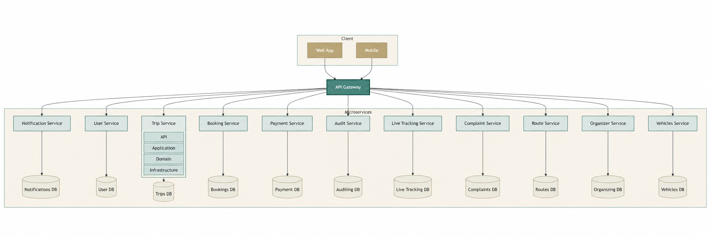

5.2.1 Entity Relationship Diagram (ERD)
The following diagram illustrates the relationships between the main entities used within the system database. 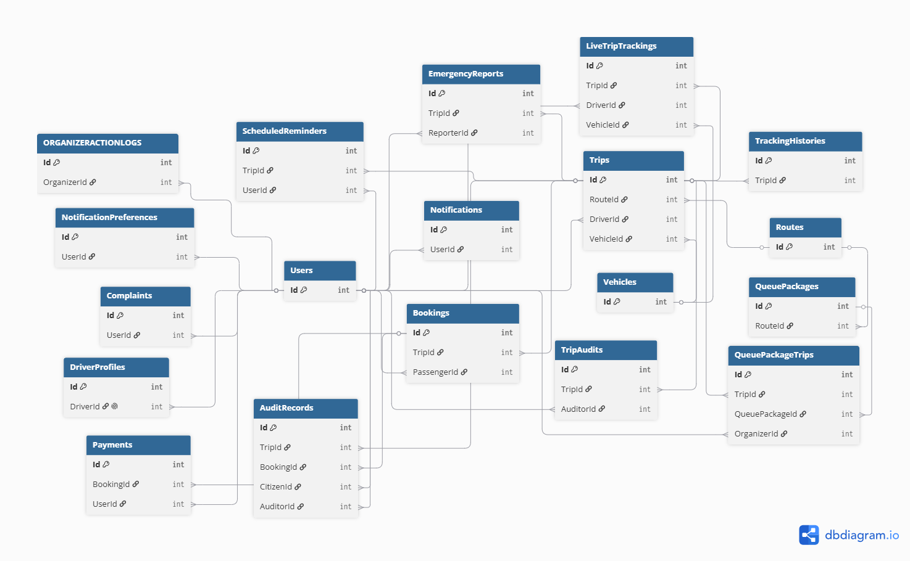

5.2.4 class diagram high level
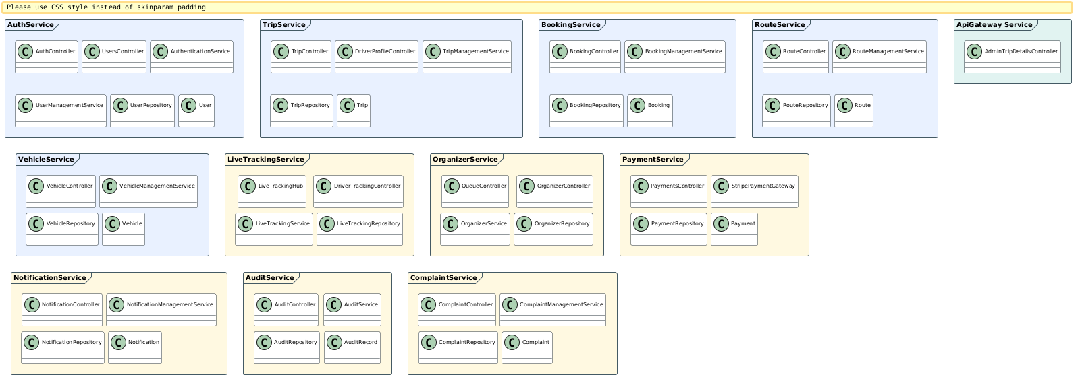
Figure 10 class digram
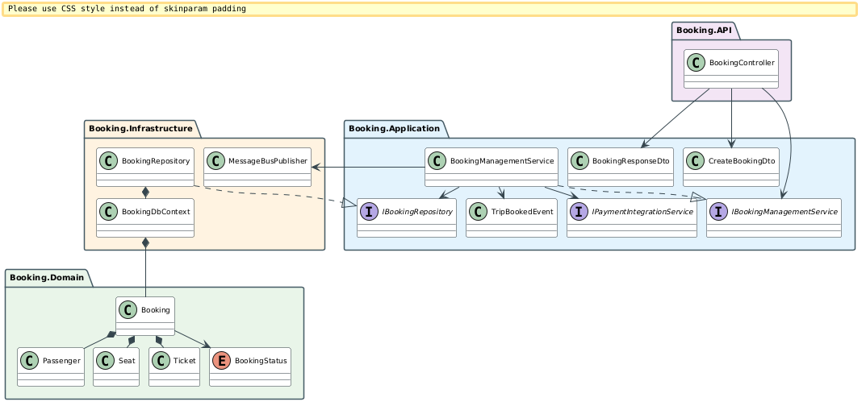
Figure 11 class diagram servece Booking
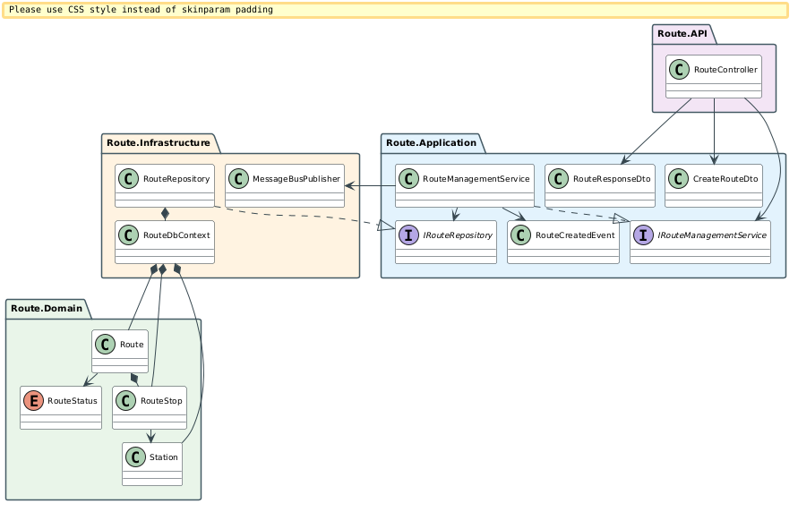
Figure 12 class diagram service route

5.3 API Design
The system exposes RESTful APIs to enable communication between the frontend application and backend microservices.
Each API endpoint follows REST architectural principles and uses standard HTTP methods such as: (GET – POST – PUT – DELETE)
Authentication APIs
Endpoint | Method | Description | Parameters | Return Value | Error Codes
/api/auth/register | POST | Register a new user | User registration data | JWT token and user information | 400, 409
/api/auth/login | POST | Authenticate user login | Email, password | JWT access token | 400, 401

User Management APIs
Endpoint | Method | Description | Parameters | Return Value | Error Codes
/api/users/drivers | GET | Retrieve all drivers | JWT token | List of drivers | 401, 403
/api/users/drivers | POST | Create a new driver | Driver information | Created driver object | 400, 401
/api/users/drivers/{id} | PUT | Update driver information | Driver ID, updated data | Updated driver object | 400, 404
/api/users/drivers/{id} | DELETE | Delete a driver | Driver ID | Deletion confirmation | 404
/api/users | GET | Retrieve all users | JWT token | List of users | 401, 403
/api/users/by-ids | POST | Retrieve users by IDs | List of user IDs | User objects | 400
/api/users/{id} | GET | Retrieve user by ID | User ID | User information | 404
/api/users/{id} | PUT | Update user information | User ID, updated data | Updated user object | 400, 404
/api/users/{id} | DELETE | Delete user | User ID | Deletion confirmation | 404
/api/users/me | GET | Retrieve current user profile | JWT token | Current user profile | 401
/api/users/me | PUT | Update current user profile | Updated profile data | Updated profile | 400, 401
/api/users/admin-contact | GET | Retrieve administrator contact information | JWT token | Contact information | 404

5.3.2 BookingService APIs
Endpoint | Method | Description | Parameters | Return Value | Error Codes
/api/booking | GET | Retrieve all bookings | JWT token | List of bookings | 401
/api/booking/{id} | GET | Retrieve booking by ID | Booking ID | Booking details | 404
/api/booking/my | GET | Retrieve current user's bookings | JWT token | User bookings | 401
/api/booking/my/active | GET | Retrieve active bookings | JWT token | Active bookings | 401
/api/booking/my/history | GET | Retrieve booking history | JWT token | Historical bookings | 401
/api/booking/trip/{tripId} | GET | Retrieve bookings for a trip | Trip ID | Trip bookings | 404
/api/booking | POST | Create a new booking | Booking information | Booking details | 400, 409
/api/booking/cancel | POST | Cancel a booking | Booking ID | Cancellation confirmation | 400, 404

5.3.3 ComplaintService APIs
Endpoint | Method | Description | Parameters | Return Value | Error Codes
/api/complaint | GET | Retrieve all complaints | JWT token | List of complaints | 401
/api/complaint/{id} | GET | Retrieve complaint by ID | Complaint ID | Complaint details | 404
/api/complaint/my | GET | Retrieve current user's complaints | JWT token | User complaints | 401
/api/complaint | POST | Create a new complaint | Complaint information | Complaint details | 400
/api/complaint/{id}/status | PATCH | Update complaint status | Complaint ID, status | Updated complaint | 400, 404
/api/complaint/{id}/respond | PATCH | Respond to a complaint | Complaint ID, response | Updated complaint | 400, 404

5.3.4 RouteService APIs
Endpoint | Method | Description | Parameters | Return Value | Error Codes
/api/route | GET | Retrieve all routes | JWT token | List of routes | 401
/api/route/{id} | GET | Retrieve route by ID | Route ID | Route details | 404
/api/route | POST | Create a new route | Route information | Created route | 400
/api/route/{id} | PUT | Update route information | Route ID, updated data | Updated route | 400, 404
/api/route/{id} | DELETE | Delete route | Route ID | Deletion confirmation | 404

5.3.7 HTTP Response Codes
Status Code | Meaning
200 OK | Request completed successfully
201 Created | Resource created successfully
400 Bad Request | Invalid request data
401 Unauthorized | Authentication required
403 Forbidden | Access denied
404 Not Found | Requested resource not found
409 Conflict | Data conflict occurred
500 Internal Server Error | Unexpected server-side error

5.4 Security and Authorization Design
Security and access control were considered critical aspects during the design and implementation of the proposed system. The system was designed to ensure secure communication between users and backend services while protecting sensitive information and restricting unauthorized access.
The security architecture is based on authentication, authorization, role-based access control, and secure API communication mechanisms.

5.4.1 Authentication Mechanism
The system uses JSON Web Token (JWT) authentication to verify user identities and secure access to protected resources.
When a user successfully logs into the system, the AuthService generates a JWT access token containing the user's identity and assigned role. The generated token is then returned to the client application and attached to subsequent API requests using the Authorization header.
The token contains encoded claims such as:
- User Identifier
- User Role
- Token Expiration Time
- Security Metadata
This mechanism enables stateless authentication and improves scalability in the microservices architecture.

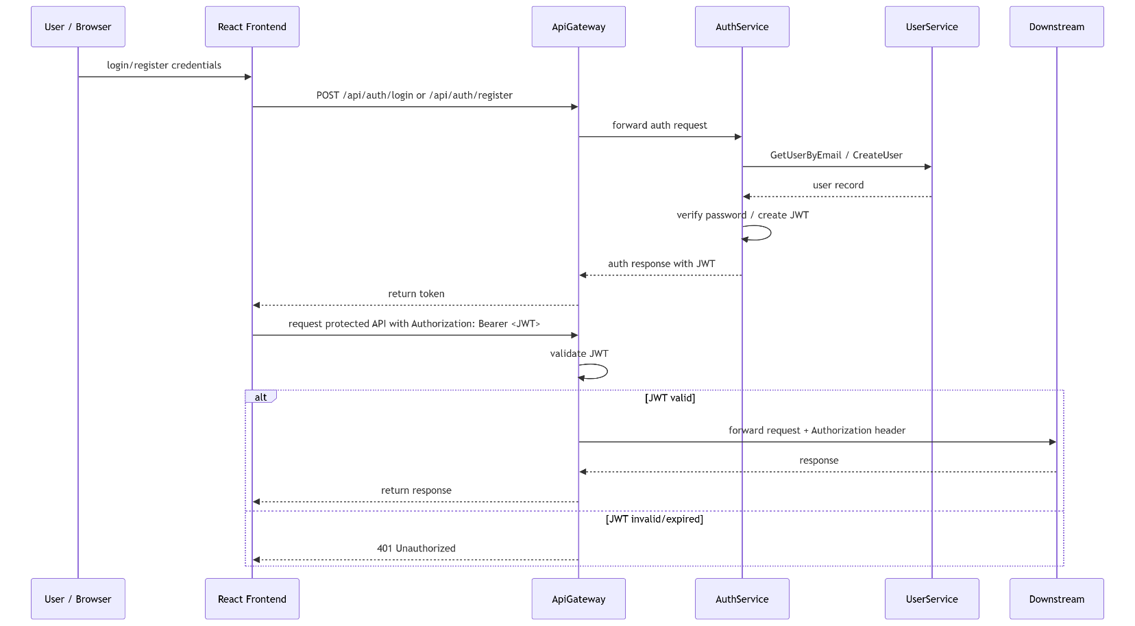
Figure 13 jwt Athentication and Authorization

The authentication workflow follows these steps:
- The user submits login credentials through the frontend application.
- The AuthService validates the provided credentials.
- A JWT access token is generated upon successful authentication.
- The frontend stores the token securely and includes it in future requests.
- The API Gateway validates the token before forwarding requests to backend services.
This approach improves security and minimizes repeated authentication requests between services.

5.4.2 Authorization and Access Control
The system implements Role-Based Access Control (RBAC) to regulate access to system resources and functionalities.
Each authenticated user is assigned a specific role that determines the operations and resources they are permitted to access.
The main user roles implemented in the system are:
Role | Description
Admin | Has full access to system management functionalities
Driver | Manages trips, driver profile, and transportation-related operations
User | Can book trips, submit complaints, and manage personal information
Authorization rules are enforced at both the API Gateway and microservice levels to ensure secure access control.
Protected endpoints require valid authentication tokens and appropriate permissions before access is granted.

5.4.3 Access Levels
Different access levels were implemented to protect sensitive operations and system resources.
Administrative Access
Administrative users have elevated privileges that allow them to:
- Manage users and drivers
- Create and update routes
- Manage vehicles and trips
- View system-wide data and reports
- Handle complaints and notifications
Driver Access
Drivers are granted permissions related to transportation management, including:
- Viewing assigned trips
- Managing driver profiles
- Updating trip statuses
- Accessing route information
User Access
Regular users can perform standard platform operations such as:
- Booking trips
- Viewing booking history
- Submitting complaints
- Managing personal profile information

5.4.4 API Security Measures
Several additional security measures were implemented to improve system protection, including:
- Password hashing
- Secure JWT token validation
- HTTP based communication
- Input validation and request sanitization
- Protected API routes
- Token expiration handling
- Exception and error handling mechanisms
Sensitive operations such as updating passwords or deleting records require authenticated requests and proper authorization privileges.

5.4.5 Security Architecture Overview
The overall security architecture ensures confidentiality, integrity, and controlled access to system resources while maintaining scalability and performance within the distributed microservices environment.
The combination of JWT authentication, role-based authorization, API Gateway validation, and protected service communication provides a secure foundation for the proposed transportation management system

Chapter 6

DEVELOPMENT ENVIRONMENT AND TOOLS

6.1 Introduction
This chapter presents the development environment, tools, frameworks, and technologies used in the implementation of the Departure Center System. The objective of this chapter is to provide a complete technical overview of the system setup in order to ensure reproducibility and maintainability.

6.2 Development Tools and Software
The following tools were used during system development:
- Visual Studio Code (VS Code): Primary code editor used for both frontend and backend development.
- Postman: Used for testing and validating RESTful API endpoints.
- Docker: Used for containerizing microservices and managing system dependencies.
- k6: Used for performance and load testing of the system APIs.
These tools were essential in ensuring efficient development, testing, and deployment workflows.

6.3 Development Environment and System Structure
The system was developed in a hybrid environment using both Windows OS and Windows Subsystem for Linux (WSL). WSL was primarily used to run Docker containers efficiently.
The project structure follows a microservices-based architecture with a clear separation between frontend, backend, and testing components.

6.3.1 Root Directory Structure
The root directory of the project contains the main system components as follows:
DepartureCenterSystemCopy/
├── backend/ # All backend microservices
├── frontend/ # React frontend application
├── k6-tests/ # Performance testing scripts
This structure ensures clear separation between system layers and simplifies development and deployment processes.

6.3.2 Backend Structure
The backend is implemented using a microservices architecture. Each service is independently developed and deployed.
backend/
├── ApiGateway/
├── AuthService/
├── UserService/
├── BookingService/
├── ComplaintService/
├── NotificationService/
├── RouteService/
├── TripService/
├── VehicleService/
Each service is responsible for a specific business domain, and all communication between services is handled through the API Gateway.

6.3.3 Microservice Internal Architecture
Each microservice follows a Clean Architecture pattern consisting of four main layers:
ServiceName/
├── ServiceName.Api/ # REST API layer (Controllers, Middleware)
├── ServiceName.Application/ # Business logic (Services, Interfaces, DTOs)
├── ServiceName.Domain/ # Domain models (Entities, Enums, Interfaces)
└── ServiceName.Infrastructure/ # Data access & external services (Persistence, HttpClients)
This layered architecture ensures:
- Separation of concerns
- High maintainability
- Testability of business logic
- Independent development of layers

6.3.4 Frontend Structure
The frontend is built using React with Vite and follows a modular component-based structure.
frontend/
├── public/ # Static assets
├── src/
│ ├── components/ # Reusable React components
│ ├── context/ # React Context for state management
│ ├── data/ # Mock/sample data
│ └── assets/ # Images, fonts, etc.
This structure improves code reusability and maintains a clean separation between UI components and application logic.

6.3.5 Performance Testing Structure
Performance testing is implemented using k6 and organized in a dedicated directory:
k6-tests/
├── utils/ # Test utilities and helpers
└── scenarios/ # Test scenarios and configurations
This structure allows the definition of multiple load testing scenarios and reusable testing utilities to evaluate system performance under different conditions.

6.4 Programming Languages and Frameworks
The system was implemented using the following technologies:
Backend
- Language: C#
- Framework: .NET 8
- Architecture: Clean Architecture (4-layer structure)
Frontend
- Languages: HTML, CSS, JavaScript
- Framework: React (Vite-based setup)
API Communication
- RESTful APIs
- JSON-based data exchange
- HTTP protocols

6.5 Database Server and Operating System
Database
- SQL Server was used as the primary database management system.
- Each microservice has its own dedicated database to ensure data isolation and scalability.

6.6 Dependencies and Libraries
The frontend project uses a modern JavaScript ecosystem managed through package.json.
These dependencies support:
- UI development (React)
- Styling (TailwindCSS)
- API communication (Axios)
- Routing (React Router)
- Code quality (ESLint)
- Build tooling (Vite)

6.7 Version Control and Source Code Management
The system uses:
- Git for version control
- GitHub for repository hosting and collaboration
The project follows a structured branching strategy to manage development and feature integration. Each microservice and frontend module is tracked independently to ensure modular development.

6.9 Testing Environment
The system was tested in a local development environment.
Testing Setup
- Backend services were containerized using Docker
- Services were executed locally using localhost
- API testing was performed using Postman
- Load and performance testing were conducted using k6
Performance Testing
k6 scripts were used to simulate multiple concurrent users in order to evaluate system performance under load conditions.
Execution Environment
- Local machine (using WSL)
- Docker containers running microservices locally


SQL Server
Postman
Java script
Docker
React
.NET
CSS3




HTML5




6.10 Summary
The development environment was carefully selected to support scalability, modularity, and efficient microservices development. The combination of .NET 8, React, SQL Server, Docker, and modern development tools provided a robust foundation for implementing the Departure Center System.

Chapter 7

Software Implementation

7.1 Project and File Structure
The DepartureCenterSystem project follows a modular microservices architecture based on the Clean Architecture pattern. The system is divided into independent backend services, a frontend client application, and performance testing modules. This structure improves scalability, maintainability, and separation of concerns.
Root Directory Structure

DepartureCenterSystemCopy/
├── backend/ # All backend microservices
├── frontend/ # React frontend application
├── k6-tests/ # Performance testing scripts
Backend Structure
The backend layer contains all microservices responsible for handling business operations and system functionalities.
backend/
├── ApiGateway/
├── AuthService/
├── UserService/
├── BookingService/
├── ComplaintService/
├── NotificationService/
├── RouteService/
├── TripService/
├── VehicleService/
Each microservice follows a standardized 4-layer Clean Architecture structure:
ServiceName/
├── ServiceName.Api/ # REST API Layer
├── ServiceName.Application/ # Business Logic Layer
├── ServiceName.Domain/ # Domain Models Layer
└── ServiceName.Infrastructure/ # Data Access & External Services Layer
Layer Responsibilities
Layer | Responsibility
API Layer | Handles HTTP requests, controllers, middleware, and routing
Application Layer | Contains business logic, DTOs, interfaces, and services
Domain Layer | Defines entities, enums, and core domain models
Infrastructure Layer | Manages database access, repositories, migrations, and external integrations
Frontend Structure
The frontend application was implemented using React with Vite.
frontend/
├── public/ # Static files
├── src/
│ ├── components/ # Reusable UI components
│ ├── context/ # Global state management
│ ├── data/ # Mock/sample data
│ └── assets/ # Images and static resources
Performance Testing Structure
The system uses k6 for load and performance testing.
k6-tests/
├── utils/ # Shared test utilities
└── scenarios/ # Load testing scenarios
Service Communication Structure
The system uses an API Gateway pattern for centralized routing between the frontend and backend services.
User Request
↓
Frontend (React)
↓
ApiGateway (Ocelot)
├─→ AuthService
├─→ UserService
├─→ BookingService
├─→ ComplaintService
├─→ NotificationService
├─→ RouteService
├─→ TripService
└─→ VehicleService
Each microservice owns a separate SQL Server database to ensure service isolation and independent deployment.

7.2 Modules Implementation
The system was implemented using independent microservices, where each service is responsible for a specific business domain. This modular design improves maintainability, scalability, and fault isolation.

7.2.1 API Gateway
The API Gateway was implemented using Ocelot to provide centralized request routing, authentication forwarding, and communication management between the frontend and backend services.
Main Responsibilities
- Request routing
- JWT authentication forwarding
- Reverse proxy functionality
- Unified API entry point
- Service abstraction from frontend clients

7.2.2 Authentication Service
The AuthService is responsible for user authentication and JWT token generation.
Main Functionalities
- User registration
- User login
- JWT token generation
- Role-based authorization
- Token validation
JWT Implementation Example
var tokenDescriptor = new SecurityTokenDescriptor
{
Subject = new ClaimsIdentity(new[]
{
new Claim(ClaimTypes.NameIdentifier, user.Id.ToString()),
new Claim(ClaimTypes.Role, user.Role)
}),
Expires = DateTime.UtcNow.AddHours(2),
SigningCredentials = new SigningCredentials(
new SymmetricSecurityKey(
Encoding.UTF8.GetBytes(jwtSettings.SecretKey)),
SecurityAlgorithms.HmacSha256Signature)
};

7.2.3 Booking Service
The BookingService manages all booking-related operations within the system.
Main Functionalities
- Create bookings
- Cancel bookings
- Retrieve booking details
- Manage passenger reservations
- Validate booking states
Booking Creation Logic
public async Task<BookingDto> CreateBookingAsync(CreateBookingDto dto)
{
var booking = new Booking
{
PassengerId = dto.PassengerId,
TripId = dto.TripId,
PassengerName = dto.PassengerName,
Status = BookingStatus.Confirmed,
BookedAt = DateTime.UtcNow
};
await _bookingRepository.AddAsync(booking);
await _bookingRepository.SaveChangesAsync();
return MapToDto(booking);
}

7.2.4 Trip Service
The TripService manages trip scheduling and trip-related operations.
Main Functionalities
- Create trips
- Manage trip schedules
- Assign drivers
- Retrieve trip information
- Validate trip capacity

7.2.5 Vehicle Service
The VehicleService is responsible for vehicle management and tracking.
Main Functionalities
- Vehicle registration
- Vehicle updates
- Vehicle assignment
- Capacity management
Controller Example
[HttpGet("{id}")]
public async Task<IActionResult> GetById(Guid id)
{
var vehicle = await _vehicleService.GetVehicleByIdAsync(id);
if (vehicle == null)
return NotFound();
return Ok(vehicle);
}

7.3 API Implementation
The system APIs were implemented using ASP.NET Core Web API following RESTful principles.
API Characteristics
- Attribute-based routing
- JWT authentication
- Role-based authorization
- Asynchronous operations
- Dependency injection
- Standard HTTP status codes
Controller Implementation Example
[ApiController]
[Route("api/[controller]")]
public class AuthController : ControllerBase
{
private readonly IAuthenticationService _authService;
public AuthController(IAuthenticationService authService)
{
_authService = authService;
}
[HttpPost("login")]
[AllowAnonymous]
public async Task<IActionResult> Login(LoginDto request)
{
var result = await _authService.LoginAsync(request);
return Ok(result);
}
}
HTTP Methods Used
Method | Purpose
GET | Retrieve resources
POST | Create resources
PUT | Update resources
DELETE | Remove resources

Common HTTP Status Codes
Status Code | Description
200 OK | Successful request
201 Created | Resource created successfully
400 Bad Request | Invalid request
401 Unauthorized | Authentication required
403 Forbidden | Access denied
404 Not Found | Resource not found
500 Internal Server Error | Unexpected server error

7.4 Data Access Layer Implementation
The data access layer was implemented using Entity Framework Core with SQL Server databases.
DbContext Example
public class BookingDbContext : DbContext{
public DbSet<Booking> Bookings { get; set; }
protected override void OnModelCreating(ModelBuilder modelBuilder){
modelBuilder.Entity<Booking>(entity => {
entity.HasKey(e => e.Id);
entity.Property(e => e.PassengerName)
.IsRequired()
.HasMaxLength(150);
entity.HasIndex(e => e.CancellationCode)
.IsUnique();
});
}
}
EF Core Features Used
- DbContext and DbSet mapping
- Database migrations
- LINQ queries
- Asynchronous database operations
- Entity relationships and constraints

7.5 Business Logic Layer Implementation
The business logic layer was implemented inside the Application layer of each microservice.
Main Responsibilities
- Input validation
- Business rule enforcement
- DTO mapping
- Inter-service communication
- Exception handling
- Logging

7.6 User Interface Implementation
The frontend application was implemented using React and Vite to provide a responsive and interactive user interface.
Frontend Technologies
Technology | Purpose
React | User interface development
Vite | Frontend build tool
React Context API | State management
Axios | API communication
CSS | Styling and layout

Main Frontend Components
- Authentication pages
- Trip management pages
- Booking interfaces
- Complaint management
- Dashboard interfaces
Example React Component
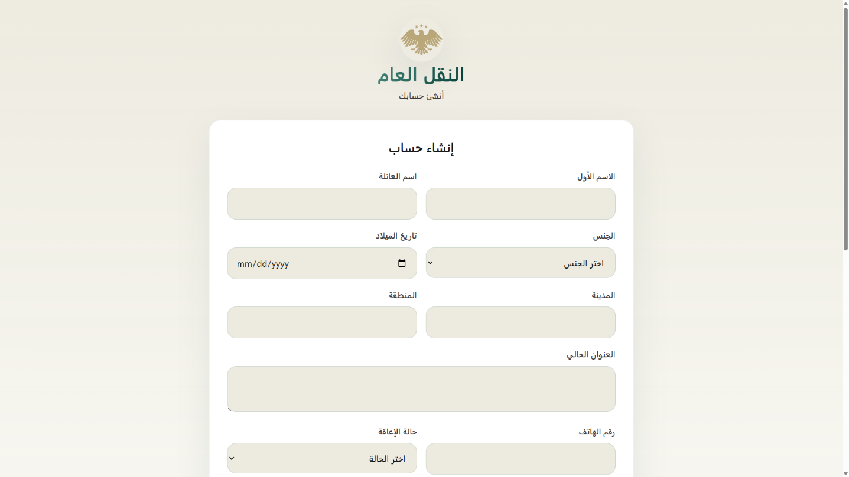
Table 27 interface register
2.login
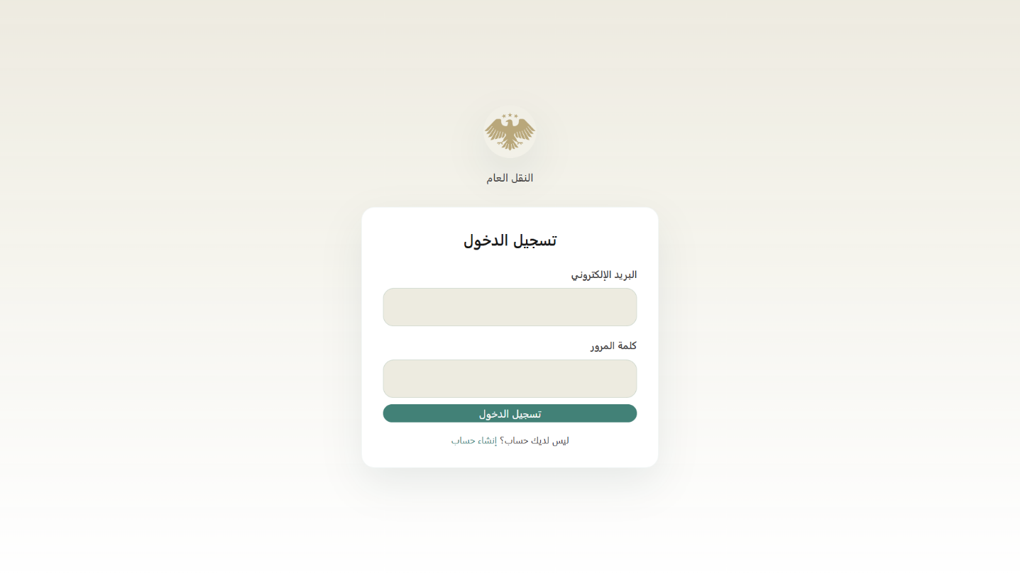
Table 28 interface login

3.Admin Manage route 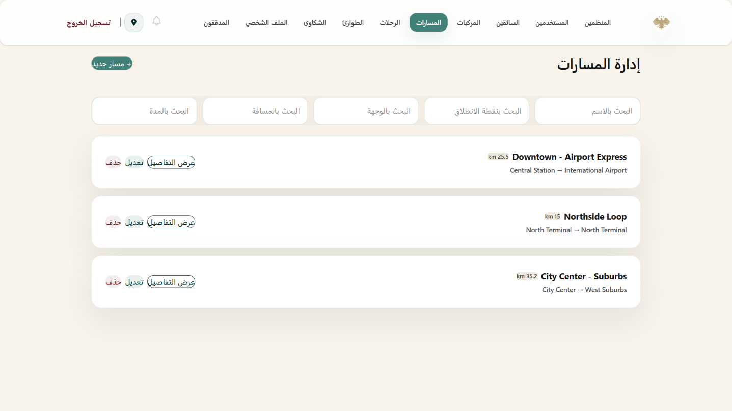
Table 29 interface booking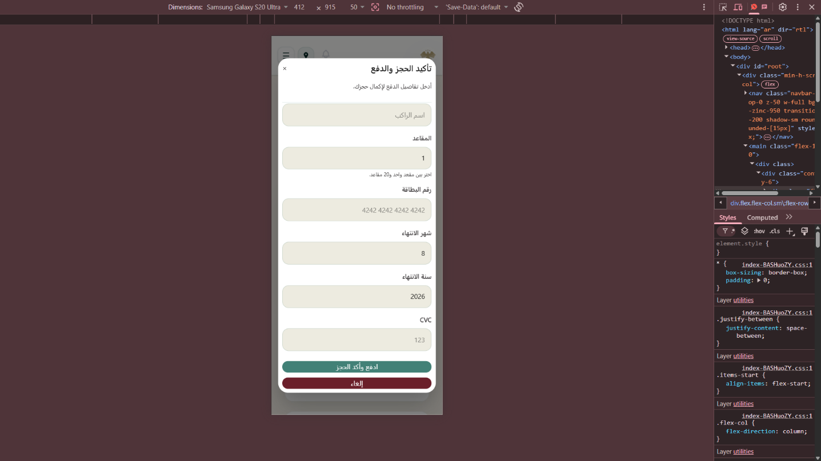Table 30 interface booking mobile

Auditor 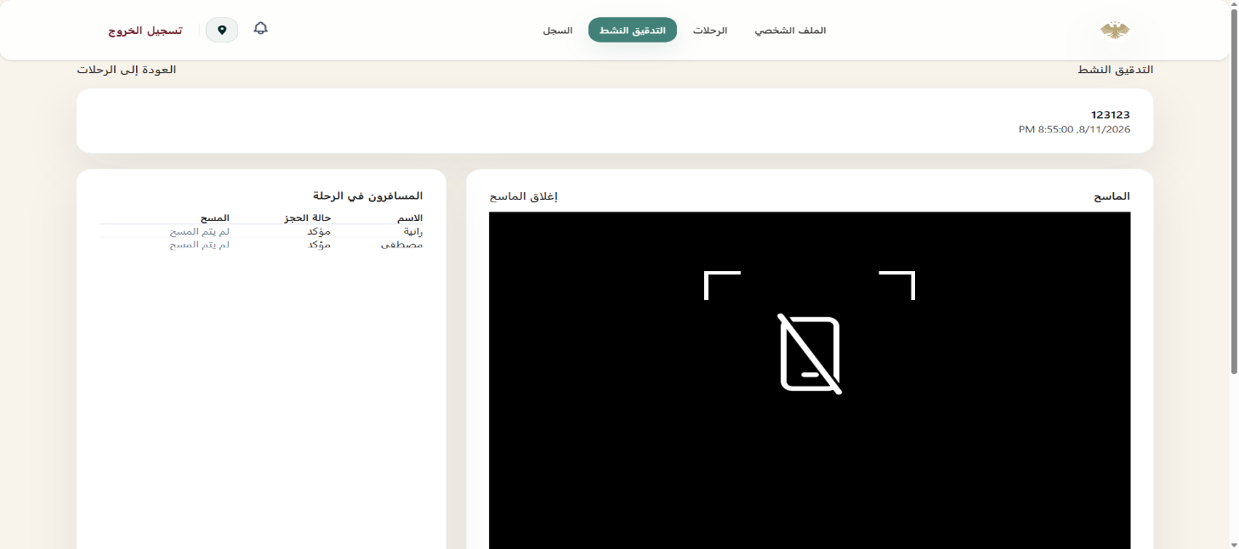
Table 31 interface audit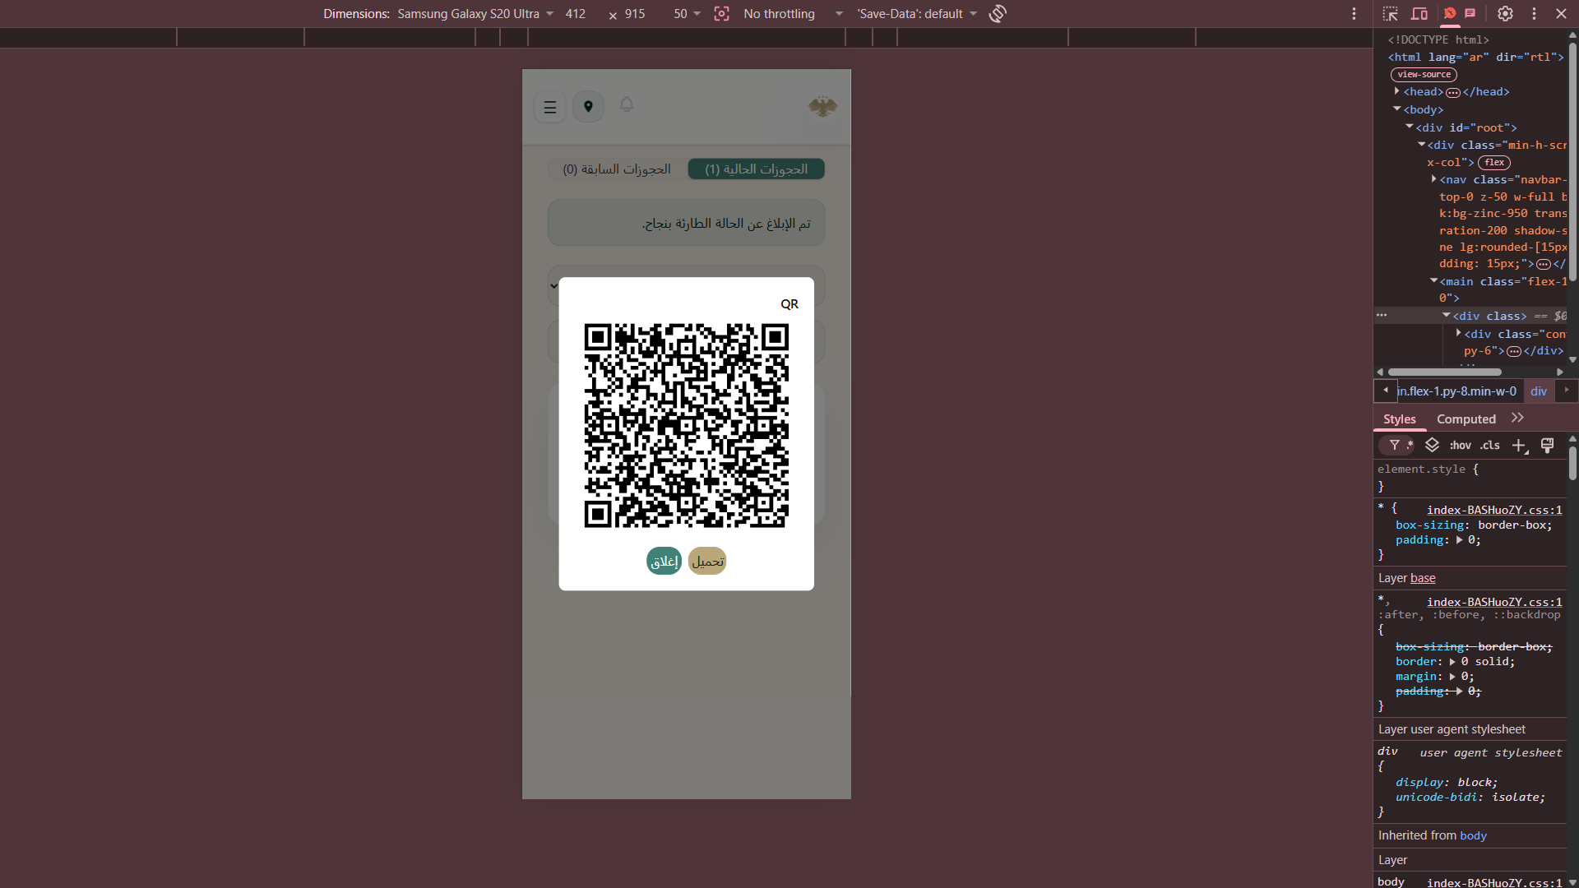

Organizer
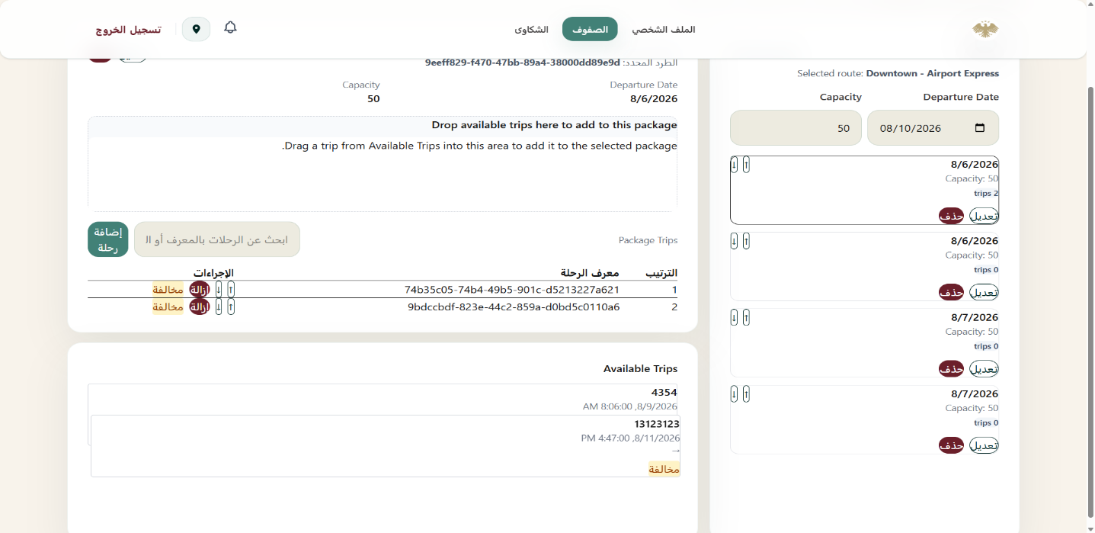
Table 32 interface manage queue
Live tracking 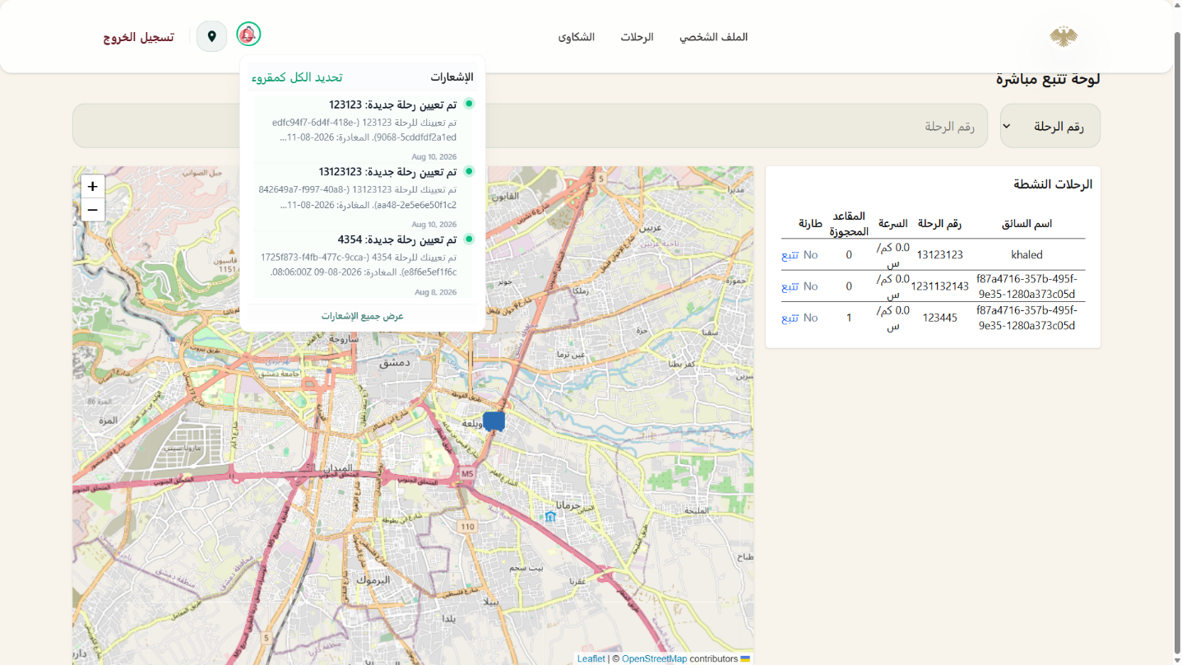
Table 33 interface live tracking
Notifications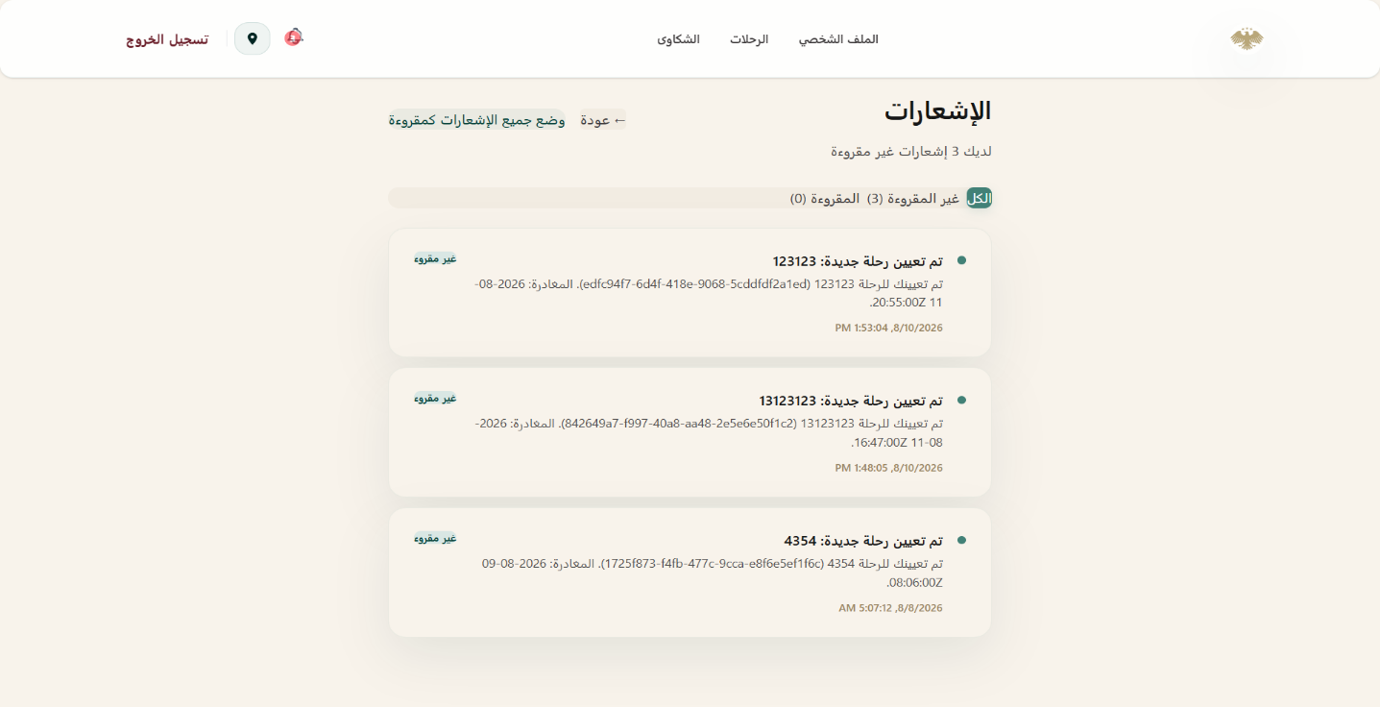
Table 34 notification

7.7 Performance Testing Implementation
The system performance was tested using k6 load testing scripts.
Testing Objectives
- Measure API response time
- Evaluate concurrent user handling
- Detect bottlenecks
- Test system stability under load
Testing Scenarios
- Concurrent booking requests
- Authentication stress testing
- Trip retrieval performance
- Gateway routing performance

7.8 Summary
The DepartureCenterSystem implementation follows a scalable microservices architecture combined with Clean Architecture principles. The system was implemented using ASP.NET Core, React, SQL Server, Docker, and Entity Framework Core. Each service was independently structured and deployed, enabling better maintainability, scalability, and extensibility. The use of JWT authentication, API Gateway routing, repository patterns, dependency injection, and load testing tools contributed to building a robust and production-oriented software system.

Chapter 8

Testing

and Evaluation

8.1 Testing Plan
The testing phase of the Departure Center System project was designed to ensure that the system functions correctly, performs efficiently under different workloads, and maintains acceptable security and reliability standards. The testing process focused primarily on API validation, performance testing, load testing, and security assessment.
The testing activities were performed throughout the development lifecycle to continuously validate system stability and functionality.
Testing Objectives
The main objectives of the testing process were:
- Verify that all APIs function correctly
- Ensure stable communication between microservices
- Validate authentication and authorization mechanisms
- Measure system performance under different workloads
- Detect bottlenecks and performance limitations
- Evaluate system behavior during stress conditions
- Assess the security posture of exposed APIs
Testing Tools Used
Tool | Purpose
Postman | Manual API testing and endpoint validation
k6 | Load and performance testing
Docker Compose | Test environment orchestration

8.2 Types of Tests
The project included multiple categories of testing to evaluate different aspects of the system.

8.2.1 Functional Testing
Functional testing was performed manually using Postman to validate API behavior and business workflows.
Functional Testing Scope
- User registration
- User authentication
- JWT token validation
- Trip retrieval
- Booking creation
- Complaint submission
- Authorization and role validation

Test cases
Table 35 test cases
Test Case ID | Use Case ID | Test Case Name | Preconditions | Test Steps | Test Data | Expected Result | Status
TC-01 | UC-01 | Add Queue Organizer with valid complete data | User is logged in as Garage Manager. | 1. Navigate to Add Queue Organizer page. 2. Fill in all required fields. 3. Click 'Save'. | Name: "Samer Al-Ahmad" Email: samer@test.com Phone: "0991234567" | Queue Organizer is saved successfully, appears in the list, and can log in. | PASS
TC-02 | UC-01 | Add Queue Organizer with missing required fields | User is logged in as Garage Manager. | 1. Navigate to Add Queue Organizer page. 2. Leave name or email empty.3. Click 'Save'. | Name: "Email: "samer@test.com" | Validation error message appears requesting required fields; data is not saved. | PASS
TC-03 | UC-01 | Add Queue Organizer with already existing email | User is logged in as Garage Manager; email already exists in DB. | 1. Enter an existing email address.  2. Click 'Save'. | Email: "existing_org@test.com" | Error message appears: 'Email already in use'; operation fails. | PASS
TC-04 | UC-02 | Update Queue Organizer name and phone number successfully | Selected Queue Organizer exists in the system. | 1. Select an existing Queue Organizer. 2. Modify name and phone number. 3. Click 'Update'. | New Name: "Samer Updated" Phone: "0998765432" | Information updated successfully and new details display in the list. | PASS
TC-05 | UC-02 | Update Queue Organizer with invalid email format | Selected Queue Organizer exists in the system. | 1. Change email to an invalid format.  2. Click 'Update'. | Email: "user@com" | System rejects the update and displays an invalid email format warning. | PASS
TC-06 | UC-02 | Cancel update operation without saving | Selected Queue Organizer edit form is open. | 1. Modify some fields. 2. Click 'Cancel' or close window. | Modified Name: "Temp Name" | Original data remains unchanged without saving modifications. | PASS
TC-07 | UC-03 | Delete Queue Organizer with confirmation | Queue Organizer is not managing any active queue. | 1. Click 'Delete' next to Organizer. 2. Confirm deletion in popup prompt. | Target Organizer ID: #101 | Organizer is completely removed from list and login access is revoked. | PASS
TC-08 | UC-03 | Cancel deletion prompt for Queue Organizer | Queue Organizer list is displayed. | 1. Click 'Delete' next to Queue Organizer.  2. Select 'Cancel' in confirmation prompt. | Target Organizer ID: #102 | Deletion process stops and the organizer remains in the list. | PASS
TC-09 | UC-03 | Delete Queue Organizer assigned to an active queue | Organizer is actively managing a queue. | 1. Attempt to delete an organizer managing an active queue. | Target Organizer ID: #103 (Active) | Deletion blocked with message: 'Cannot delete organizer managing an active queue'. | PASS
TC-10 | UC-04 | View full list of all Queue Organizers | Multiple Queue Organizers exist in system. | 1. Navigate to 'Show Queue Organizers' view. | N/A | Complete list of all registered Queue Organizers is rendered with basic details. | PASS
TC-11 | UC-04 | View list when no Queue Organizers exist | No Queue Organizers exist in DB. | 1. Access view when no organizers are registered. | N/A | Clear message displays: 'No Queue Organizers found'. | PASS
TC-12 | UC-04 | Search/filter within Queue Organizers list | Organizers list contains multiple entries. | 1. Enter a specific organizer name into search bar. | Search Query: "Ahmad" | List dynamically updates to display only matching search results. | PASS
TC-13 | UC-05 | Add new Trip Auditor with valid information | User logged in as Garage Manager. | 1. Navigate to 'Add Auditor' page. 2. Enter valid details. 3. Click 'Save'. | Name: "Omar Al-Saeed"Email: "omar@audit.com"Password: "SecurePass123!" | New Auditor account created successfully and confirmation displayed. | PASS
TC-14 | UC-05 | Add Auditor with a weak password | User logged in as Garage Manager. | 1. Enter password below minimum length.  2. Click 'Save'. | Password: "123" | Error message requires a stronger password; creation fails. | PASS
TC-15 | UC-05 | Add Auditor without selecting assigned role/permissions | User logged in as Garage Manager. | 1. Leave role selection empty.  2. Click 'Save'. | Role: null | System prompts user to select a valid role before proceeding. | PASS
TC-16 | UC-06 | Update Auditor details and permissions successfully | Target Auditor exists in DB. | 1. Select an Auditor.  2. Modify assigned audit section.  3. Click 'Save'. | Updated Section: "Express Line Auditing" | Auditor information and permissions updated successfully. | PASS
TC-17 | UC-06 | Update non-existent Auditor (deleted concurrently) | Auditor record was removed in concurrent session. | 1. Attempt saving edits for Auditor removed in another session. | Auditor ID: #205 (Deleted) | Error message: 'Auditor not found or already modified'. | PASS
TC-18 | UC-06 | Reset password for an Auditor account | Auditor exists in DB. | 1. Select Auditor and click 'Reset Password'.  2. Input new password & confirm. | New Password: "NewSecurePass2026!" | Password updated successfully; Auditor can log in with new credentials. | PASS
TC-19 | UC-07 | Delete Auditor with confirmation | Auditor has no active pending audits. | 1. Select Auditor from list.  2. Click 'Delete' and confirm. | Auditor ID: #201 | Auditor removed from list and account access revoked. | PASS
TC-20 | UC-07 | Delete Auditor with pending assigned trip audits | Auditor has assigned pending trip audits. | 1. Select Auditor with active audit assignments.  2. Confirm delete. | Auditor ID: #202 (Has Active Audits) | System blocks deletion until pending audits are reassigned. | PASS
TC-21 | UC-07 | Verify soft deletion retains historical audit logs | Auditor with past completed audit logs. | 1. Delete Auditor.  2. Inspect past audited trip records. | Auditor ID: #203 | Auditor removed from active list, but past audit logs retain original Auditor name. | PASS
TC-22 | UC-08 | View all registered Trip Auditors | Active Auditor accounts exist in DB. | 1. Open 'Show Auditors' page. | N/A | All active Auditor accounts are listed cleanly with accurate statuses. | PASS
TC-23 | UC-08 | Verify pagination control when Auditor count is high | More than 10 Auditors exist in system. | 1. Access list when > 10 Auditors exist.  2. Navigate through pages. | Total Records: 25  Page Size: 10 | Auditors paginated correctly; Next/Previous controls operate as expected. | PASS
TC-24 | UC-08 | View detailed profile and history of a specific Auditor | Auditor exists with historical audit records. | 1. Click on a specific Auditor record. | Auditor ID: #201 | Detailed profile view opens showing personal details and audit activity history. | PASS

Example API Test Cases
Test Case | Expected Result
Login with valid credentials | JWT token returned
Login with invalid password | 401 Unauthorized
Create booking with valid data | Booking successfully created
Access protected endpoint without token | 401 Unauthorized
Submit complaint | Complaint stored successfully
Example Postman Request
Login API
This endpoint is used to authenticate a user by logging them into the system. It accepts user credentials and, upon successful authentication, returns a token that can be used for subsequent requests.
Request
- Method: POST
- URL: {{authBaseUrl}}/api/Auth/login
Request Body
The request body must be in JSON format and should include the following parameters:
- email (string): The email address of the user attempting to log in.
- password (string): The password associated with the user's account.

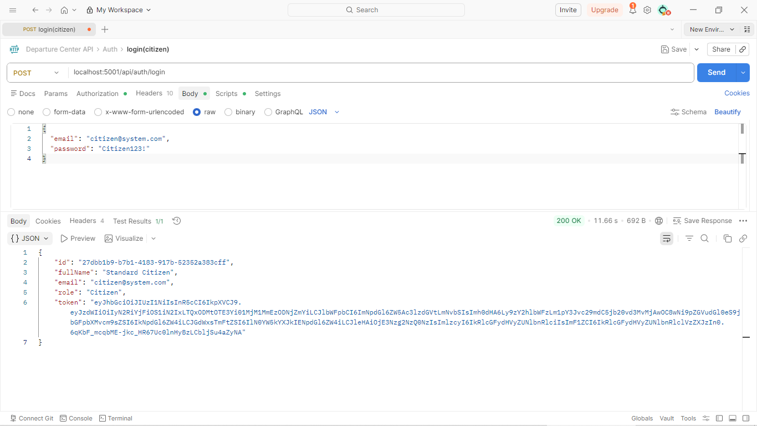

8.2.2 Performance and Load Testing
Performance testing was implemented using k6 to evaluate system responsiveness, scalability, and stability under concurrent traffic conditions.
k6 Testing Structure
k6-tests/
├── utils/
├─────helper.js
├─────config.js
└── scenarios/
├─────laod.js
├─────smoke.js
├─────spike.js
├─────stress.js
Performance Test Scenarios
The project supports multiple load-testing scenarios:
Scenario | Description
Smoke Test | Basic workflow validation
Load Test | Normal expected traffic
Stress Test | Heavy load and saturation testing
Spike Test | Sudden traffic increase and recovery testing

Test Execution
Local Execution
cd k6-tests & k6 run filename.js
Environment Variables
Variable | Description
K6_BASE_URL | API Gateway base URL
K6_USER_EMAIL | Test account email
K6_USER_PASSWORD | Test account password
K6_REGISTER | Register new user before tests
K6_SCENARIO | Selected testing scenario

Example Command
K6_BASE_URL=http://localhost:3000 \
K6_SCENARIO=load \
K6_USER_EMAIL=citizen@system.com \
K6_USER_PASSWORD=Citizen123! \
k6 run main.js
Tested Workflows
The k6 suite validates the following workflows through the API Gateway:
- User login and authentication
- Trip browsing and retrieval
- Booking creation
- Booking history retrieval
- Complaint submission
Performance Metrics
The following metrics were monitored during testing:
Metric | Description
http_req_duration p(95) | 95th percentile response time
http_req_duration avg | Average response time
http_req_failed | Request failure percentage
checks | Business validation success rate
vus | Number of virtual users
Target Thresholds
Metric | Target
p(95) Response Time | < 500ms
Average Response Time | < 350ms
Failed Requests | < 1%
Successful Checks | > 99%
Performance Results Placeholder
Smoke Test Results
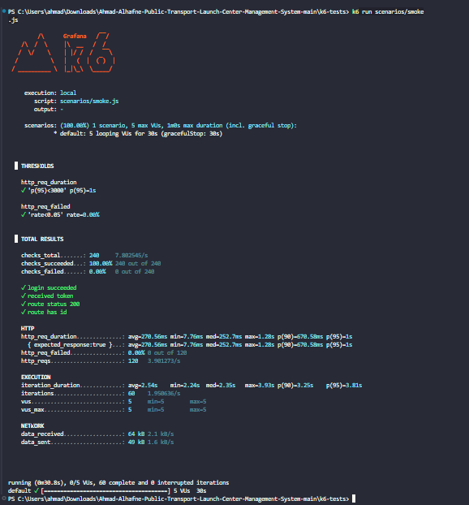

Load Test Results
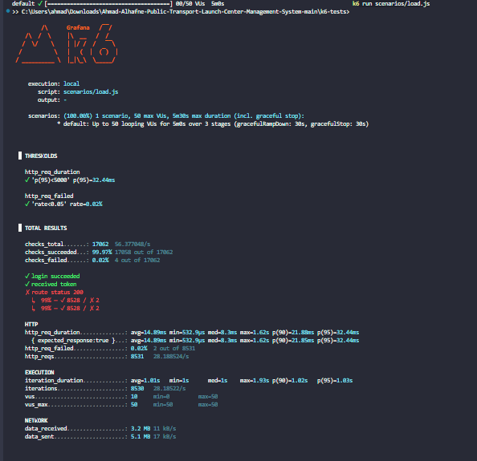

Stress Test Results
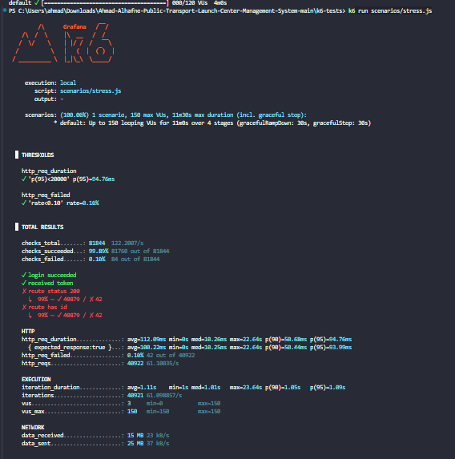

Spike Test Results
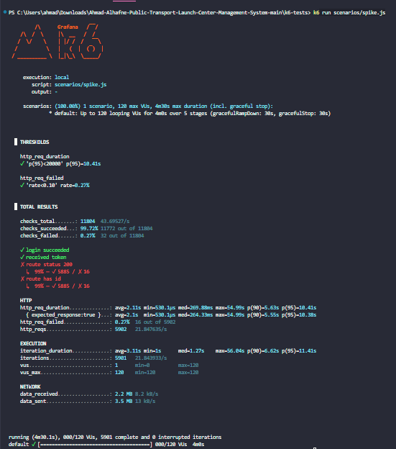

8.3 Testing Environment
The testing environment was containerized using Docker Compose to ensure consistency and reproducibility across different executions.
Test Environment Components
Component | Technology
Backend Services | ASP.NET Core Microservices
Frontend | React + Vite
Database | SQL Server
API Gateway | Ocelot
Performance Testing | k6
Containerization | Docker & Docker Compose

8.4 Testing Architecture
The testing process interacted with the system through the API Gateway to simulate real-world client behavior.
Testing Tools
(Postman / k6 )
↓
API Gateway (Ocelot)
↓
Backend Microservices
↓
SQL Server Databases
This approach ensured that all requests passed through the same routing, authentication, and communication layers used in production environments.

8.5 Test Results and Analysis
The testing process demonstrated that the system was capable of handling normal and high-load scenarios while maintaining acceptable response times and low failure rates.
The API Gateway successfully routed requests between services, and JWT authentication mechanisms operated correctly during concurrent access scenarios.
Performance testing also helped identify potential bottlenecks and resource-intensive operations that could be optimized in future improvements.

8.6 Quality Metrics
The project evaluation focused on several quality indicators.
Metric | Description
Response Time | Average API processing duration
Throughput | Number of handled requests per second
Failure Rate | Percentage of failed requests
Availability | System uptime during tests

8.7 Challenges During Testing
Several challenges were encountered during the testing phase:
- Managing concurrent requests across multiple microservices
- Maintaining stable communication between containers
- Handling authentication tokens during automated tests
- Monitoring performance bottlenecks during stress scenarios
- Configuring realistic load distributions for system simulation
These challenges were addressed through iterative optimization, improved Docker configurations, and reusable testing utilities inside the k6 test suite.

8.8 Summary
The testing and evaluation phase confirmed that the DepartureCenterSystem provides stable API behavior, scalable request handling, and secure communication mechanisms. The use of Postman, k6 enabled comprehensive evaluation of functionality, performance aspects of the system.
The performance testing infrastructure supports multiple traffic scenarios and the overall results indicate that the system architecture is suitable for scalable and maintainable deployment environments.

Chapter 9

Result and Analysis

9.1 System Application Results
The DepartureCenterSystem successfully achieved the implementation of an integrated electronic transportation management platform based on a microservices architecture. The system provides centralized management capabilities for transportation operations while supporting passengers, administrators, and transportation staff through a unified web platform.
The implemented system enables users to browse available trips, create bookings, submit complaints, and manage transportation-related operations through secure RESTful APIs and a modern frontend interface.
Main Achieved Functionalities
The final implemented system includes the following functionalities:
Module | Achieved Functionality
Authentication System | User registration, login, JWT authentication
User Management | User profile management and authorization
Trip Management | Trip creation, scheduling, and retrieval
Booking System | Booking creation and booking history
Complaint System | Complaint submission and tracking
Vehicle Management | Vehicle registration and management
API Gateway | Centralized routing and service communication
User Interface Results
The frontend application successfully provided an interactive and user-friendly interface for managing transportation operations.
Implemented Interfaces
- Login and registration pages
- Trip browsing interface
- Booking management pages
- Complaint submission pages
- Administrative management dashboard
API and System Results
The backend services successfully communicated through the API Gateway using REST APIs and JWT authentication mechanisms.
Achieved Backend Features
- Independent microservice deployment
- Service isolation using separate databases
- Secure JWT-based authentication
- Role-based authorization
- Docker containerization support
- Scalable service communication
Performance Results Summary
The testing process demonstrated acceptable performance under multiple traffic conditions.
Metric | Result
Average Response Time | 94.76 ms
P95 Response Time | 10.41 s
Failed Request Rate | 0.27%
Concurrent Users Supported | 150 Virtual Users
Successful Requests Rate | 99.73%

9.2 Comparative Analysis with Existing Systems
We currently don’t have any Analysis report to our steady application.

9.3 Achievement of Project Objectives
The project objectives defined in Chapter 1 were reviewed and evaluated against the final implementation results.
Main Objective Evaluation
Objective 1- Create an integrated information system for transportation center management
Achieved successfully through the implementation of multiple integrated backend services and centralized management capabilities.
Objective 2 -Develop an platform that facilitates travel between cities
Achieved through trip management, booking workflows, and route management functionalities.
Objective 3- Improve public transportation services
Partially achieved through automation of booking operations, complaint management, and centralized transportation management.
Future improvements such as live tracking and real-time notifications can further enhance this objective.
Technical Objectives Achievement
Technical Objective | Status
Microservices Architecture | Achieved
API Gateway Integration | Achieved
JWT Authentication | Achieved
Docker Containerization | Achieved
SQL Server Integration | Achieved
Performance Testing | Achieved
Frontend Integration | Achieved

9.4 Strengths and Weaknesses Analysis
System Strengths
The developed system includes several important strengths:
1. Scalable Architecture
The microservices architecture enables independent deployment and scaling of services without affecting the entire system.
2. Maintainability
The use of Clean Architecture improves code organization and separation of concerns, making maintenance easier.
3. Security
JWT authentication and role-based authorization provide secure access control.
4. Flexibility
The modular service design allows future extensions and additional services to be integrated easily.
5. Containerization Support
Docker support simplifies deployment and testing across different environments.
6. Performance Testing Infrastructure
The integration of k6 performance testing enables continuous monitoring of system scalability and stability.
System Weaknesses:Despite the achieved results, several limitations and weaknesses were identified.
1. Limited Real-Time Features
The current implementation does not fully support live vehicle tracking or real-time trip updates.
2. Absence of Mobile Application
The system currently focuses on a web-based platform without dedicated mobile applications.
3. Limited AI Integration
Although the architecture supports future intelligent features, the current implementation does not yet include advanced AI-based prediction or recommendation models.
4. Infrastructure Complexity
Microservices architectures increase deployment and monitoring complexity compared to monolithic systems.
5. Limited Production-scale Testing
Testing was primarily performed in development and simulated environments rather than large-scale real-world deployments.

9.5 Key Performance Indicators (KPIs)
Several KPIs were used to evaluate the system performance
Performance KPIs
KPI | Source
94.76 ms average response | Stress test sustained high load
10.41 s p95 | Worst-case spike latency
150 VUs | Maximum tested concurrency
0.27% failed requests | Highest observed failure rate
100% auth success | Smoke test login checks passed
System Quality KPIs
KPI | Description
Service Availability | Stability of backend services
API Reliability | Successful request processing
Scalability | Ability to handle increasing load
User Experience | Ease of navigation and interaction
KPI Analysis
The collected metrics indicate that the system maintained stable API responses and low failure rates under normal and moderate load scenarios. The testing infrastructure also demonstrated the ability of the platform to recover from traffic spikes and concurrent request loads.
The modular architecture contributed to better service isolation and operational stability during testing scenarios.

9.6 General Analysis
The final implementation demonstrates that the DepartureCenterSystem successfully provides an integrated transportation management platform based on modern software engineering practices.
The project combines microservices architecture, Clean Architecture principles, RESTful APIs, JWT authentication, Docker containerization, and performance testing methodologies into a unified system capable of supporting scalable transportation management operations.
The conducted tests and comparisons indicate that the system provides a strong technical foundation for future expansion toward more advanced smart transportation solutions.

Chapter 10 Conclusion & Recommendations

10-1 Conclusion
At the conclusion of this research, and thanks to God, an integrated system for managing public transport departure centers has been developed. The primary goal was to automate administrative and field operations within departure centers. The project addressed the system's lifecycle, starting from studying the current situation and analyzing functional and non-functional requirements, to software design and the implementation of user interfaces serving the five stakeholders (the manager, the driver, auditor ,organizer and the citizen).
The system helps solve issues of chaotic trip organization and provides managers with effective supervisory tools to monitor the fleet , in addition to improving passenger experience through real-time tracking and trip search features. This work represents a step towards digital transformation in the public transport sector, enhancing the efficiency of services provided to citizens.

10-2 Difficulties and challenges
Dynamics of requirements and data structuring: Difficulty emerged in converting traditional and complex paper-based mechanisms for departure garages into flexible software algorithms, especially in organizing the overlap between trip schedules, driver availability, vehicle conditions, and ensuring no data conflicts occur (data consistency).
Resource management and time constraints: Reconciling the massive scale of the required system (user management, complaints, and trips) with the limited project timeline was a real test of the team's ability to manage priorities and allocate technical tasks effectively under deadline pressure.
Accuracy of simulation to reality: The greatest challenge was in designing a user interface (UI/UX) that combines simplicity to suit garage employees with technical robustness to handle complex operations, while ensuring the security and accuracy of data entered by multiple parties.

10-3 Future Work
This system does not represent the end, but rather a cornerstone that can be developed in the future through the following prospects:
Use of Artificial Intelligence: Integrating prediction algorithms to forecast bus arrival times more accurately based on historical traffic patterns, and smartly distribute trips to reduce congestion.
Dedicated Mobile Application for Drivers: Expanding the driver app’s functions to include integrated navigation (GPS) and smart safety alerts.
Periodic Maintenance Management System: Adding a software module that notifies the manager of vehicle maintenance schedules based on kilometers recorded in the system.
10-4Recommendations for institutions:
adopt smart systems to reduce waste and prevent price manipulation, and rely on the analytical reports provided by the system to make data-driven decisions. For students: focus on studying similar systems globally before starting the design, and adhere to agile development methodologies (Iterative Incremental) to ensure continuous delivery of functional components.

Appendix A: Requirement Collection Questionnaires and Interview Outcomes
The requirements gathering process relied on a mixed methodology to ensure system comprehensiveness, and its results can be summarized as follows:
Field Interviews: A series of meetings were held with stakeholders, primarily the director of the Daraa Garage, to understand the traditional mechanism used in managing shifts, distributing trips, and documented driver and vehicle information.
Key Questions Raised: These focused on how congestion is addressed, the mechanism for citizens to submit complaints, and the methods for verifying vehicles' legal papers.
Questionnaire Outcomes: The study concluded the necessity of having a central system that connects the director, driver, and citizen in a single digital loop to ensure transparency and reduce time wastage.
Deriving Requirements: The questions posed during the analysis phase focused on:
How is the "role" organized and how are trips currently distributed?
What are the gaps in the paper-based complaint system?
What are the essential data that must be available in the record of each driver and bus?
Appendix B: Detailed Design
B-1: Main Use Case Diagrams:
The system includes comprehensive diagrams covering:
Driver Management: (Add a new driver, edit data, verify driving license).
Bus Management: (Add a bus, delete a bus, and update its status between 'Available' or 'On Trip').
Complaint System: (Submit a complaint by the citizen, and handle it by the manager).
B-2: Activity Diagrams:
Workflows were drawn for each function within the system to ensure smooth transitions between interfaces, starting from login to executing complex tasks such as trip management
First: Reference Studies and Similar Applications (Reference Study)
A set of leading global systems and platforms in the field of transportation management and logistics services were studied and analyzed to derive functional requirements and compare them:
Careem & Lyft Platforms: Studying driver management interfaces and intelligent ride organization mechanisms.
Moovit & Citymapper Applications: Analyzing public transportation routing systems and the user experience in tracking schedules.
Transit App: A reference on how to display routes and schedule departure trips for public vehicles.
Second: Tools and Technologies Used (Tools & Technologies)
These references rely on the software tools and management platforms employed to build and document the project:
GitHub Projects: The main reference for managing source code and tracking the team's programming tasks.

References

The following list represents all the scientific references, software documentation, and technical sources that were relied upon during the design, construction, and testing of the system. The references are formatted according to the IEEE standard and are listed in order of their appearance in the report.

Academic Literature & Books
[1] R. C. Martin, Clean Architecture: A Craftsman's Guide to Software Structure and Design, 1st ed. Boston, MA, USA: Prentice Hall, 2017.
[2] M. Fowler, Building Microservices: Designing Fine-Grained Systems, 2nd ed. Sebastopol, CA, USA: O'Reilly Media, 2021.
[3] I. Sommerville, Software Engineering, 10th ed. Boston, MA, USA: Pearson, 2016.
[4] IEEE Standard for System, Software, and Hardware Verification and Validation, IEEE Std 1012-2016, pp. 1-260, 2016.
Technical Documentation & APIs
[5] Microsoft, "ASP.NET Core Architecture and Web API Documentation," Microsoft Learn, 2025. [Online]. Available: https://learn.microsoft.com/en-us/aspnet/core/. [Accessed: Aug. 10, 2026].
[6] PostgreSQL Global Development Group, "PostgreSQL 16.0 Documentation," 2024. [Online]. Available: https://www.postgresql.org/docs/. [Accessed: Aug. 10, 2026].
[7] RabbitMQ, "RabbitMQ Documentation & Messaging Patterns," 2025. [Online]. Available: https://www.rabbitmq.com/documentation.html. [Accessed: Aug. 10, 2026].
[8] React Documentation Team, "React Documentation: Hooks and Components Specifications," 2025. [Online]. Available: https://react.dev. [Accessed: Aug. 10, 2026].
[9] Docker Inc., "Docker Containerization and Compose Specifications," 2026. [Online]. Available: https://docs.docker.com. [Accessed: Aug. 10, 2026].

Project Repositories & Resources
[10] Development Team, "Garage Management System - Microservices Architecture Backend," GitHub Repository, 2026. [Online]. Available: https://github.com/Ahmad-Alhafne/Public-Transport-Launch-Center-Management-System-Senior-2
[11] Development Team, "Garage Management System - Web Client Frontend," GitHub Repository, 2026. [Online]. Available: https://github.com/Ahmad-Alhafne/Public-Transport-Launch-Center-Management-System-Senior-2

[12] Postman API Network, "Garage Management System API Documentation and Test Collections," 2026. [Online]. Available: https://documenter.getpostman.com/view/example

